APPENDIX F - SIGN GUIDELINES
Types of Signs

- A sign is required during construction.
- A sign must be posted upon completion (1 & 2 could be the same if sign durable)
All Grantees are required to post a sign at the project site. The sign must be available for the final inspection of the project. There is no minimum or maximum size other than the minimum size for the logo as long as the sign contains the required wording.

Project Title/Description

Another Urban Greening project funded by Proposition 84 to Improve the Sustainability and Livability of California’s Communities

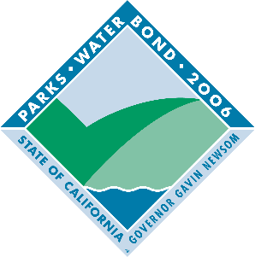

GAVIN NEWSOM, GOVERNOR
Strategic Growth Council

Language for Signs
All signs will contain the following minimum language:
The name of the director of the local agency or other governing body may also be added. The sign may also include the names (and/or logos) of other partners, funding organizations, individuals and elected representatives.

Logo
All signs must contain a universal logo for the Resources Bond Acts (see above). The logo is available at
http://www.resources.ca.gov/bonds_prop84 urbangreening.html. The logo must be mounted in an area to maximize visibility and durability. Each side of the logo must be a minimum of 1’X1’ -- exceptions may be approved when appropriate.

Sign Construction
All materials used shall be durable and resistant to the elements and graffiti. The California Department of Parks and Recreation and California Department of Transportation standards can be used as a guide for gauge of metal, quality of paints, mounting specifications, etc.

Sign Duration
Project signs must be in place for a minimum of four (4) years from date of project completion.

Sign Cost
The cost of the sign(s) is an eligible project cost. More permanent signage is also encouraged (e.g., bronze memorials mounted in stone at trailheads, on structures, etc.).

Appropriateness of Signs
For projects where the required sign may be out of place or where covered by local sign ordinances, the grants administrator in consultation with the grantee may authorize a sign that is appropriate to the project in question.

Signs on State Highways
Signs placed within the state highway right-of-way may require a Caltrans encroachment permit. Contact your local Caltrans District Office early in the planning process for more information. You can find your local Caltrans District Office by visiting http://www.dot.ca.gov/localoffice.htm.

State Approval
The Grantee shall submit proposed locations, size, number of signs and language for review prior to ordering signs. Funds for development projects will not be reimbursed until signage has been approved and installed.

