Blue Ribbon Committee for the Rehabilitation of Clear Lake
Meeting #25
May 25, 2023, 1pm-4pm*
Virtual Meeting: See Page 2 for Details

AGENDA
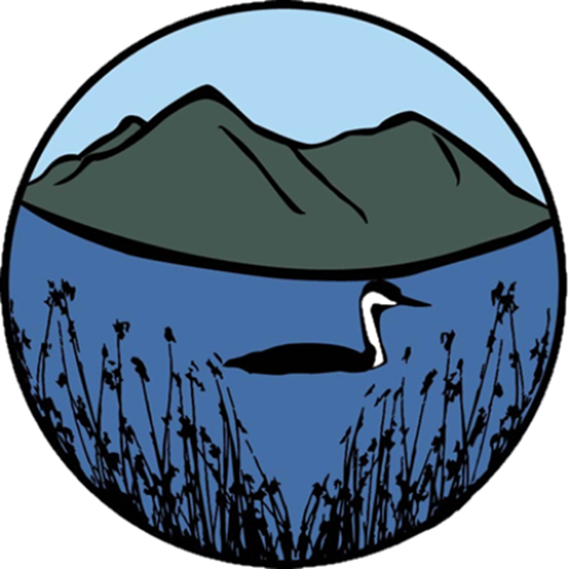
Meeting Agenda

1:00 pm: Welcome and Introductions
Eric Sklar, Committee Chair
Sam Magill, California State University, Sacramento

1:10 pm Funding Update on 2022 Committee Approved Projects
Geneva Thompson, California Natural Resources Agency
Eric Sklar
All Committee Members

1:15 pm 2023 Proposals for Consideration
- Proposal Overview and Scoring Matrix Results
- Committee Approval of Proposals
- Independent HAB Proposal Review
- Next Steps
Sam Magill
Eric Sklar
Proposal Teams
All Committee Members

3:45 pm Public Comment

3:55 pm: Action Item Review and Closing Comments

4:00 pm: MEETING ADJOURNS

REMOTE MEETING INFORMATION:

Join Zoom Meeting
https://csus.zoom.us/j/88356155534
Meeting ID: 883 5615 5534
One tap mobile
+16694449171,,88356155534# US
+16699006833,,88356155534# US (San Jose)
Dial by your location
+1 669 444 9171 US
+1 669 900 6833 US (San Jose)
+1 346 248 7799 US (Houston)
+1 719 359 4580 US
+1 253 205 0468 US
+1 253 215 8782 US (Tacoma)
+1 309 205 3325 US
+1 312 626 6799 US (Chicago)
+1 360 209 5623 US
+1 386 347 5053 US
+1 507 473 4847 US
+1 564 217 2000 US
+1 646 876 9923 US (New York)
+1 646 931 3860 US
+1 689 278 1000 US
+1 301 715 8592 US (Washington DC)
+1 305 224 1968 US
Meeting ID: 883 5615 5534
Find your local number: https://csus.zoom.us/u/kp6Xrp2jI

