GGRF – Funding Recognition

All Grantees are required to post a sign at the project site. The sign must be available for the final inspection of the project. There is no minimum or maximum size other than the minimum size for the logo as long as the sign contains the required wording and is legible to visitors.

Types of Signs
- A sign is required during construction.
- A sign must be posted upon completion (1 & 2 could be the same if sign is durable)

Project Title/Description

Another project funded by California Climate Investments through the California Natural Resources Agency’s
Urban Greening Program

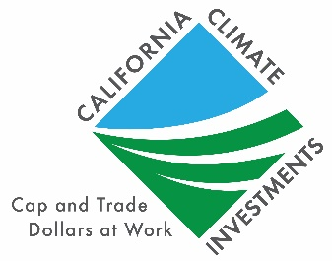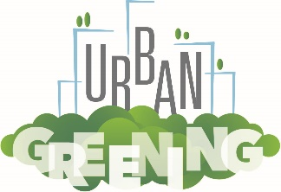

GAVIN NEWSOM, GOVERNOR
Wade Crowfoot, Secretary for Natural Resources

Language for Signs
All signs will contain the following minimum language:
The name of the director of the local agency or other governing body may also be added. The sign may also include the names (and/or logos) of other partners, funding organizations, individuals and elected representatives.

Logo
All signs must contain a universal logo for California Climate Investments and the Urban Greening Program logo (see the box to the right). The logos are available at http://resources.ca.gov/grants/logo-art/.The logos must be mounted in an area to maximize visibility and durability. Each side of the logo must be a minimum of 1’X1’ -- exceptions may be approved when appropriate.

Sign Construction
All materials used shall be durable and resistant to the elements and graffiti. The California Department of Parks and Recreation and California Department of Transportation standards can be used as a guide for gauge of metal, quality of paints, mounting specifications, etc.

Sign Duration
Project signs must be in place for a minimum of four (4) years from date of project completion.

Sign Cost
The cost of the sign(s) is an eligible project cost. More permanent signage is encouraged.

Appropriateness of Signs
For projects where the required sign may be out of place or where covered by local sign ordinances, the grants administrator in consultation with the grantee may authorize a sign that is appropriate to the project in question.

Signs on State Highways
Signs placed within the state highway right-of-way may require a Caltrans encroachment permit. Contact your local Caltrans District Office early in the planning process for more information. Visit http://dot.ca.gov/hq/construc/districtmap.htm to locate your Caltrans District Office.

State Approval
The Grantee shall submit proposed locations, size, number of signs, language, and design for review prior to ordering signs. Funds for development projects will not be reimbursed until signage has been approved and installed.

Program Recognition
The Grantee shall use the text below, in conjunction with the California Climate Investments logo and the Urban Greening logo on any project announcements, flyers, and new releases.

“The Urban Greening Program is part of California Climate Investments, a statewide program that puts billions of cap-and-trade dollars to work reducing greenhouse gas emissions, strengthening the economy and improving public health and the environment—particularly in disadvantaged communities. The cap-and-trade program also creates a financial incentive for industries to invest in clean technologies and develop innovative ways to reduce pollution. California Climate Investment projects include affordable housing, renewable energy, public transportation, zero-emission vehicles, environmental restoration, more sustainable agriculture, recycling and much more. At least 35 percent of these investments are made in disadvantaged and low-income communities. For more information, visit California Climate Investments.”

