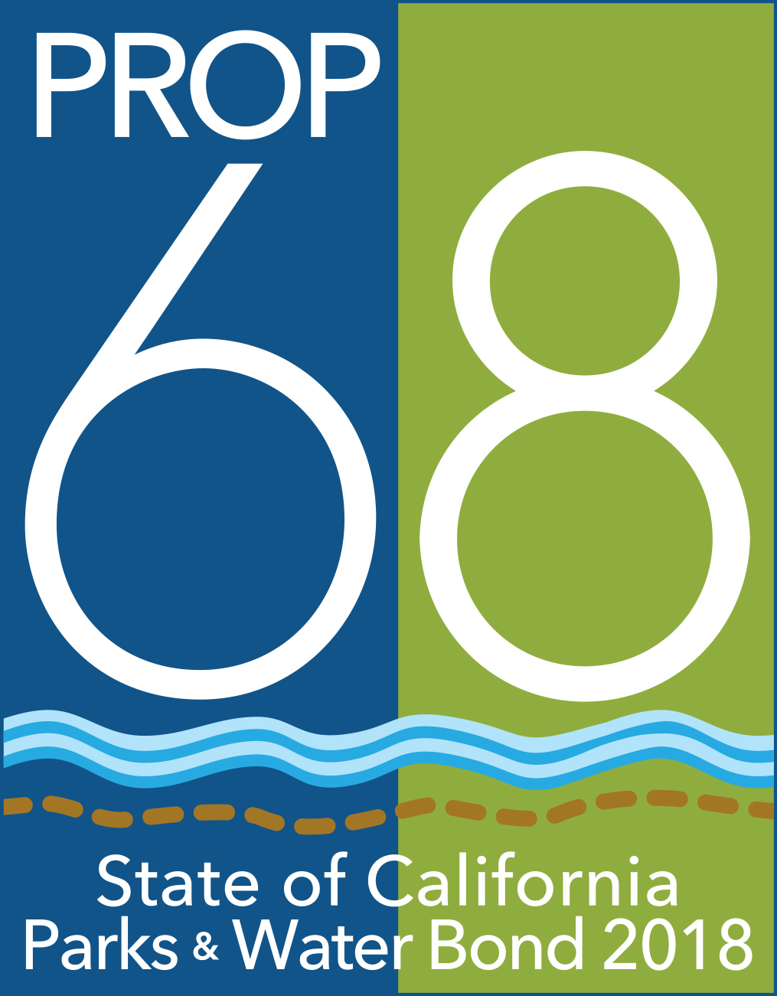**PROTECTING CALIFORNIA’S RIVERS, STREAMS, AND WATERSHEDS Grant Program**

**NOTICE OF PUBLIC COMMENT PERIOD AND PUBLIC HEARINGS**

The California Natural Resources Agency is pleased to release for public comment its draft guidelines for the Protecting California’s Rivers, Streams, and Watersheds grant program.

The Protecting California’s Rivers, Streams, and Watersheds grant program, funded by Proposition 68, will improve instream flows at ecologically important times, primarily between January through June, to help restore natural aquatic or riparian functions for aquatic species, and protect or promote the recovery of endangered or threatened species. It is the intent of the people of California that projects funded by Proposition 68, including the Protecting California’s Rivers, Streams, and Watersheds Grant Program, result in public benefits addressing the most critical statewide needs and priorities for public funding.

Draft guidelines can be downloaded at:

<https://resources.ca.gov/grants/healthy-watersheds>

Public comments and final recommendations will be considered for adoption by the Secretary for Natural Resources.

**PUBLIC COMMENT PERIOD**

The public comment period begins ***Monday******October 3, 2022*** and ends ***Friday November 18, 2022***. Written comments may be submitted by e-mail to[bondsandgrants@resources.ca.gov](mailto:bondsandgrants@resources.ca.gov)or by U.S. mail to Protecting California’s Rivers, Streams, and Watersheds grant program, California Natural Resources Agency, 715 P Street, Sacramento, CA 95814.

**PUBLIC HEARINGS**

|  |  |
| --- | --- |
|  |  |
| **NORTHERN CALIFORNIA**  Monday, November 7, 2022  1:00 p.m. – 3:00 p.m.  [REGISTER HERE](https://teams.microsoft.com/registration/UlYdt4NLV0KvzX_Rd4hFZA,deSpv6Gma0GN0ZP6IvRDZA,-xm1APWSUUOmUJ8IbrYcKA,0Rej3lUwmU26g5itAeYayA,Mq_GKsC5NEGKDK7fuPIIJA,OTveN1ID-0S4frzkuS4OpQ?mode=read&tenantId=b71d5652-4b83-4257-afcd-7fd177884564&webinarRing=gcc) | **SOUTHERN CALIFORNIA**  Tuesday, November 8, 2022  10:00 a.m. – 12:00 p.m.  [REGISTER HERE](https://teams.microsoft.com/registration/UlYdt4NLV0KvzX_Rd4hFZA,deSpv6Gma0GN0ZP6IvRDZA,-xm1APWSUUOmUJ8IbrYcKA,9qG2zaettUKPFXKmZeCiFw,PxPq9DGuyUaX4DDOhvK-_w,R7gIh9m1702A_IrA5vh28A?mode=read&tenantId=b71d5652-4b83-4257-afcd-7fd177884564&webinarRing=gcc) |
| **CENTRAL VALLEY**  Thursday, November 10, 2022  11:00 a.m. – 1:00 p.m.  [REGISTER HERE](https://teams.microsoft.com/registration/UlYdt4NLV0KvzX_Rd4hFZA,deSpv6Gma0GN0ZP6IvRDZA,-xm1APWSUUOmUJ8IbrYcKA,rUej-F7BJk-yNN4Xl4791A,dqDewv8HWEWPPvXumgL-0Q,GO435VnnRUa_XgI3BjbJow?mode=read&tenantId=b71d5652-4b83-4257-afcd-7fd177884564&webinarRing=gcc) |  |

**Additional information can be found at** <https://resources.ca.gov/grants/healthy-watersheds>

**Or by calling:** (916) 653-2812 **or emailing:** [bondsandgrants@resources.ca.gov](mailto:bondsandgrants@resources.ca.gov)