**Welcome: 9:00am-9:05am**

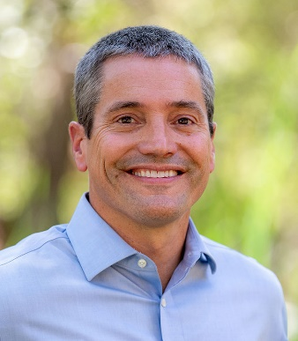

**Wade Crowfoot** serves as California’s Natural Resources Secretary, leading efforts to conserve California’s environment and natural resources. He has served as Secretary since 2019 and advises Governor Newsom as a member of his cabinet.

Secretary Crowfoot oversees an agency of over 25,000 employees spread across 26 departments, commissions, and conservancies. His agency is charged with stewarding California’s forests and natural lands, rivers and water supplies, and coast and ocean. It also protects natural places, wildlife and biodiversity, and helps oversee the state’s world-leading clean energy transition.

Secretary Crowfoot is leading efforts to achieve Governor Newsom’s ambitious environmental vision, including a commitment to conserve 30 percent of California’s land and coastal waters by 2030. He oversees billions of dollars of public investment to protect people and natural places from climate change impacts, and has led efforts to navigate California’s record-breaking droughts, floods, and wildfires. Secretary Crowfoot has also initiated a new era of partnerships with California Native American Tribes and is shifting how the agency operates to better support all California residents and communities.

Secretary Crowfoot has been on the frontlines of environmental leadership throughout his career. He served in Governor Jerry Brown’s Administration as deputy cabinet secretary and senior advisor to the Governor, driving climate action. He led the non-profit Water Foundation to build water resilience across the American West. He spearheaded efforts to establish and defend California’s landmark climate change policies as West Coast regional director for the Environmental Defense Fund.  As an environmental advisor to then-San Francisco Mayor Gavin Newsom, he helped establish many first-in-the-nation urban environmental policies. Secretary Crowfoot received a bachelor’s degree from the University of Wisconsin-Madison and a master’s degree from the London School of Economics.

Wade grew up in Michigan spending summers at a YMCA camp and in the woods around his family’s remote cabin in Northern Ontario. He moved to California in the mid-1990s and discovered backcountry camping with friends. His first time in the redwoods at Big Basin State Park is still one of his defining California moments. He loves to camp with his wife and daughter and learn new things in the outdoors, currently including fly fishing and soon backcountry skiing. He says his best days in as Natural Resources Secretary are spent outdoors with local groups that are conserving land and connecting people to nature.

**9:05-9:20 Corrina Gould, Confederated Villages of Lisjan Chairperson and Sogorea Te' Land Trust Director (15 mins)**

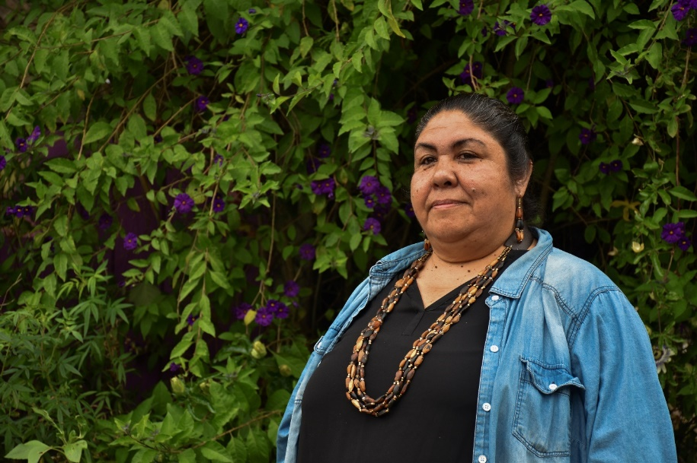

**Corrina Gould** (Tribal Chair for the Confederated Villages of Lisjan Nation), was born and raised in the village of Huichin, now known as Oakland CA. She is the Co-Founder and Lead Organizer for Indian People Organizing for Change, a small Native run organization and the Sogorea Te’ Land Trust, an urban Indigenous women-led organization within her ancestral territory. Through the practices of rematriation, cultural revitalization, and land restoration, the Land Trust calls on Native and non-Native peoples to heal and transform legacies of colonization, genocide, and to do the work our ancestors and future generations are calling us to do.

**9:30-10:30**

**Session 1: Weaving the Future Confronting the Past: Historical Wrongs and**

**Cultural Humility**

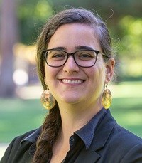

**Geneva E. B. Thompson** (she/her/hers) joined the California Natural Resources Agency in June 2021 as the Deputy Secretary for Tribal Affairs. In this role, Geneva will cultivate and ensure the participation and inclusion of tribal governments and communities within the work of the California Natural Resources Agency. She recently served as Associate General Counsel for the Yurok Tribe, where she practiced environmental and cultural resource law and represented the Yurok Tribe in tribal, state, and federal forums. She also served as Staff Attorney for the Wishtoyo Foundation, and clerked with the Department of Justice Indian Resource Section, the Natural Resources Defense Council, Earthjustice, and the Tribal Law and Policy Institute. Geneva graduated from the University of California, Los Angeles School of Law, with specializations in Critical Race Studies and Public Interest Law and Policy. She has published several law review articles and has served in leadership positions across multiple bar associations, including the National Native American Bar Association, California Indian Law Association, and the American Bar Association. Geneva is a citizen of the Cherokee Nation and enjoys beading, gardening, and hiking with her spouse in state and national parks.

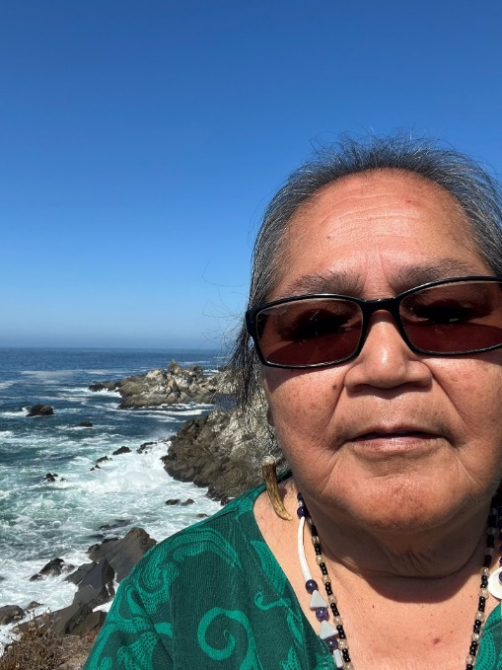

**Atta Stevenson** serves at the pleasure of the Cahto Tribe as elected Member at Large. She participated as wildlife trail co leader for Inter- tribal Sinkyone Wilderness BOD. Has provided traditional seaweed training to various tribes. She has practiced traditional conservation, stewardship and public cultural awareness to numerous non native groups. She currently serves as Just Transition team for UC Davis. Serves as Cohort for UC Berkeley COEQWAL. Recently finished a docuseries Regarding Indian Boarding School Survivors in the West.

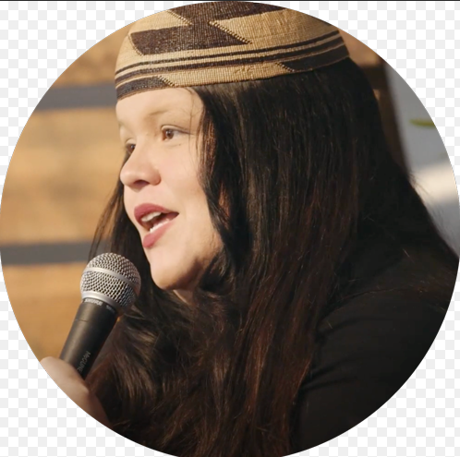

**Cutcha Risling Baldy** is an Associate Professor of Native American Studies at Cal Poly Humboldt who researches Indigenous feminisms, California Indians, Environmental Justice, Traditional Ecological Knowledge and decolonization. She is the Co-Director of the NAS Rou Dalagurr Food Sovereignty Lab & Traditional Ecological Knowledges Institute. Over the past year she has developed the strategic and fundraising plan for the lab and has worked with students to successfully raise over $400,000 to implement the lab at Cal Poly Humboldt. She is currently a Guiding Leader for the Humboldt County Office of Education Native American Studies Model Curriculum project and a Principal Investigator for several grant projects including the Food for Indigenous Futures Project which looks at connections between food justice, food sovereignty, mental health, and substance abuse prevention for Native American Youth. Her book: We Are Dancing For You: Native feminisms and the revitalization of women's coming-of-age ceremonies received "Best First Book in Native American and Indigenous Studies" at the 2019 Native American Indigenous Studies Association Conference. She received her Ph.D. in Native American Studies from UC Davis; her M.F.A. in Creative Writing & Literature from San Diego State University and her BA in Psychology from Stanford University. She is Hupa, Karuk, and Yurok and enrolled in the Hoopa Valley Tribe.

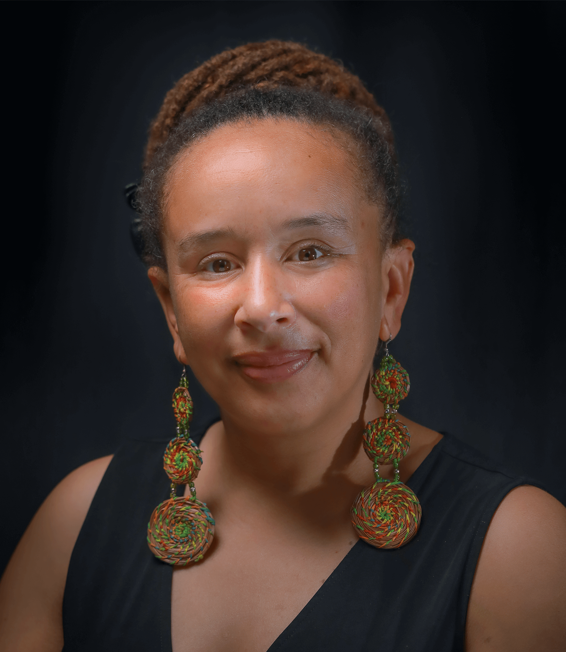

**Dr. Beth Rose Middleton Manning** is a Professor of Native American Studies at UC Davis. Her research centers on the environmental justice impacts of water infrastructure and policy, using environmental laws and processes for protection of cultural places and lifeways in the US and Caribbean, assessing and improving environmental health impacts, and collaborating on climate adaptation with Native nations and communities. She has published articles on Indigenous environmental justice, environmental/tribal law, history and environmental policy, and two books with University of Arizona Press, *Trust in the Land: New Directions in Tribal Conservation*(2011), and *Upstream: Trust Lands and Power on the Feather River*(2018)

**11:00-12:00**

**Session 2: Tribal Training Room - Legal Considerations for Ancestral Land Return and Establishing Tribal Land Trust**

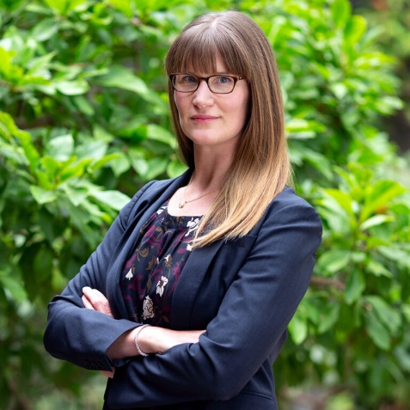

**Sara A. Clark** is a partner at Shute, Mihaly & Weinberger LLP, a public interest law firm dedicated to representing non-profit organizations, Tribes, and public agencies, based in San Francisco. She has worked extensively with Tribes, Tribal organizations, and land trusts on efforts to protect the state's cultural and natural resources, especially on land transactions and stewardship. Sara also serves as the Chair of the Board of Directors for Save the Redwoods League.

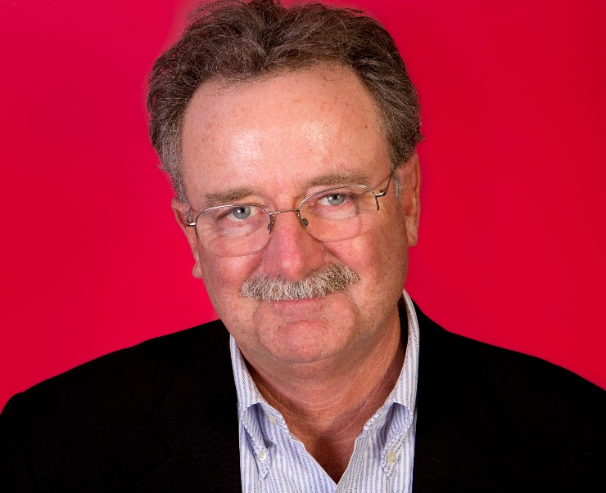

**Scott Williams** represents exclusively Indian tribes and tribal organizations throughout the United States. Currently, the firm is actively engaged with Indian tribes and nations in New York, New Mexico, Colorado, Utah, and California. A graduate of Stanford University and Boston College Law School, Scott has spent the last several decades working for Indian tribes primarily on matters related to water, water rights, fishing rights, environmental restoration, and Indian lands. Among other matters, since 1993, Scott and his colleagues in the firm have represented the Yurok Tribe in its efforts to reestablish a healthy Klamath River and its fishery, and, with the Tribe, celebrate the removal of the Klamath River dams.

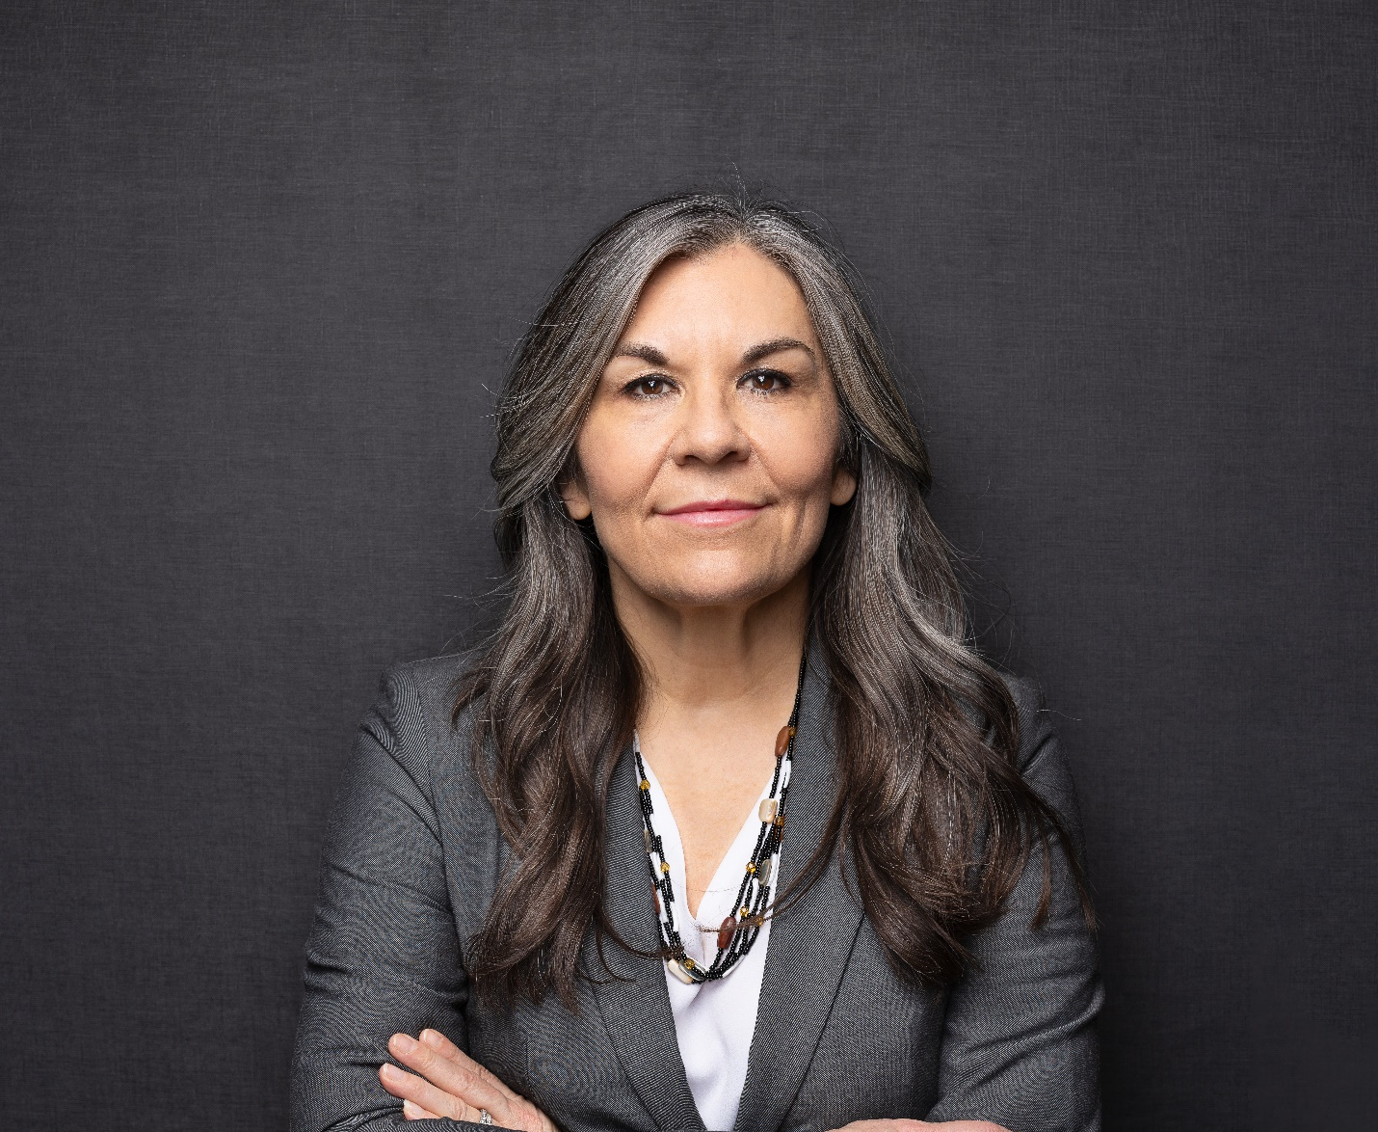**Michelle C. Lee** is a member of the Pit River Tribe and a descendant of the Cabazon Band of Mission Indians. She has been representing tribal governments for over 25 years and has owned and operated an Indian law practice since 2006. As a new attorney in 1999, she negotiated her first tribal-state gaming compact with the State of California and has successfully negotiated many amendments to other gaming compacts since that time. In addition, she has negotiated a wide variety of government-to-government agreements on behalf of tribes, including agreements with cities, counties, State Parks, and federal agencies. Michelle is also extensively involved in developing statewide policy in California regarding cultural resources protection including drafting, negotiating, and ensuring the passage of improved cultural preservation laws such as burial site protection and consultation requirements for new projects. She served as a trainer with the Governor’s Office of Planning and Research regarding the implementation of SB 18, a statewide general planning law that she drafted in collaboration with Governor Gray Davis’s Legal Affairs Department in 2004. Michelle was recently appointed to the Executive Committee of the Real Property Section of the California Lawyers Association. In July 2023, she was also appointed to the Board of Directors for the Center for Natural Lands Management which protects and manages nature preserves in the states of California and Washington. Her work in the real property law field, particularly her work on land acquisition for tribal entities and seeking new property tax exemptions, continues to inspire her desire to Indigenize real property law. Michelle received her B.A. in 1993 and her J.D. in 1998, both from the University of California, Davis. She was a recipient of the 2015 Truman Capote Creative Writing Fellowship and earned her M.F.A. in Creative Writing from the Institute of American Indian Arts in 2017. Last, but not least, Michelle is also a published author of poetry, fiction and creative non-fiction, and she has written law review articles, essays and non-fiction articles on topics relative to her work with California Indian tribes.

**11:00-12:00**

**Session 2: Non-Tribal Land Trust Room - State Polices to Strengthen Partnerships with California Native American Tribes**

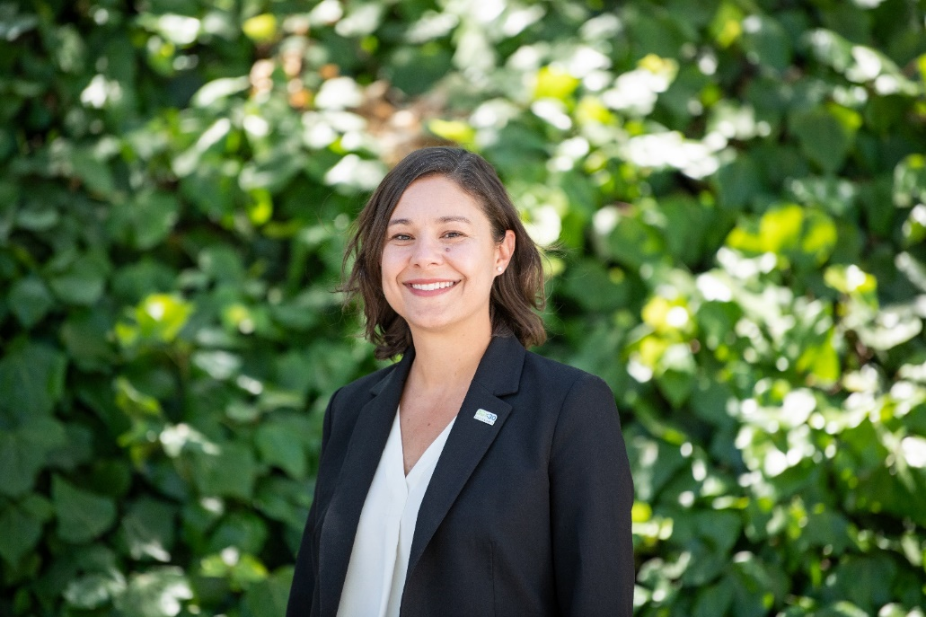

**Meghan Hertel** joined the California Natural Resources Agency in February 2024 as Deputy Secretary of Biodiversity and Habitat. In this role, Meghan leads the Agency’s efforts to conserve biodiversity and improve habitat across the state through the implementation of California’s 30x30 strategy and associated efforts including the Cutting Green Tape initiative and supporting the implementation of large-scale habitat projects. Before joining the Agency, Meghan served as North American Director for Land Life, a technology-driven, nature restoration company, and spent over a decade with Audubon California holding several positions including Director of Land and Water Conservation, where she led statewide conservation programs focused on inland water and working lands strategies. In her free time, you can find Meghan and her husband enjoying California’s incredible outdoors—backpacking, biking and paddleboarding—or trying to keep up with their foster dogs. Meghan holds a Master of Arts in Environmental Science and Policy from Clark University and a Bachelor of Arts in Political Science from the University of Florida

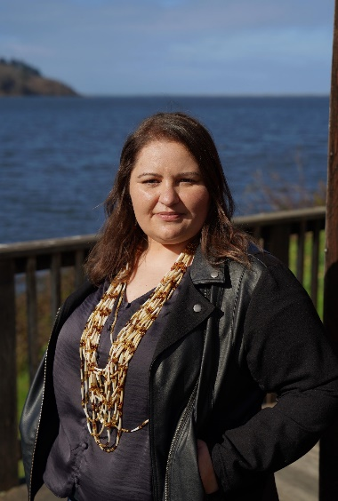

**Rosie Clayburn** is a culture practitioner who is deeply rooted in her traditions, family and community. Rosie’s mother, a Yurok language speaker and former high school teacher, raised her daughter to in the Yurok lifeway. Since she was a child, she has fished on the Klamath River, gathered from the coast and participated in same ceremonies as her ancestors.

Rosie descends from both Yurok and Tolowa people and maintains a close connection with her lineage. She is a comes from the Yurok village of Tue-rep on the Klamath River and Tolowa village of Mvs-yee-dvn on the Smith River. At a very young age, the proud Yurok Tribal citizen committed her life to cultural preservation and revitalization. Today, she leads the Yurok Tribe’s Cultural Division. As the Director of the Division, Rosie is charged with protecting the Tribe’s traditional resources for all future generations. Rosie is entering her second term on the Board of Directors for Parks California and recently joined the Save the Redwoods Council.

Rosie’s professional career started in 2003, when she was selected to intern in her Tribe’s Cultural Resources Program and now has worked for the Yurok Tribe for more than 20 years. Simultaneously, she completed a Master of Art in Museology from the University of Washington and Bachelor of Science in Anthropology, with a concentration in Archaeology and Cultural Resource Management.

As the Tribe’s Principal Investigator, she has completed numerous cultural resources studies regarding Traditional Cultural Properties and Traditional Landscapes throughout Yurok ancestral territory. As the leader of ongoing Repatriation efforts, she has returned home thousands of cultural items from institutions and private collections. She has also worked at the National Museum of the American Indian, Burke Museum, and Woodland Park Zoo. Additionally, Rosie has developed and designed numerous interpretive projects. Currently, she is overseeing the Chah-pekw O’ Ket’-toh (Stone Lagoon) Visitor, the first Tribally operated Visitor Center in the California State Park system and the ‘O Rew Redwoods Gateway Project, the first of its kind agreement with Save The Redwoods League and Redwood National and State Park to build out an interpretive hub for the Parks and Yurok Territory. Her career revolves around the protection of Cultural Resources, through an indigenous perspective, for future generations.

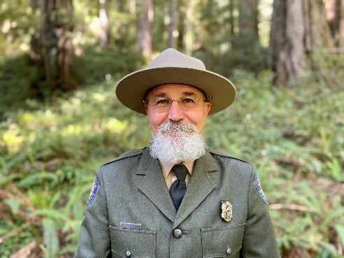

**Victor M. Bjelajac**, District Superintendent, North Coast Redwoods, California State Parks Victor Bjelajac has been with California State Parks since 2007. His collaborative work with resources and programs that spanned management jurisdictions began in earnest in 2008 and included work with local tribes, federal, state and local agencies as well as non-profit organizations. He has been involved with the development of One Tam, Redwoods Rising and California Landscape Stewardship Network collaboratives and continues working in partnership to manage landscape scale resource projects and programs with partners in California’s North Coast region. He is a Registered Professional Archaeologist and has a B.A. and M.A. in Anthropology from San Francisco State University.

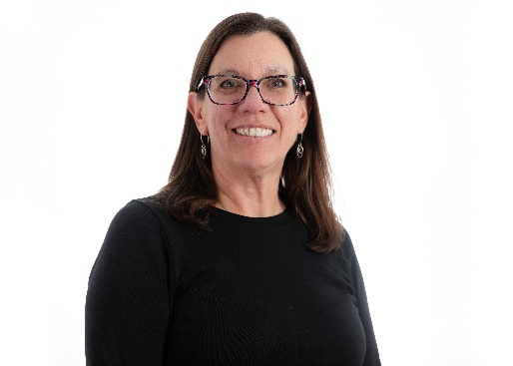

**Amy Hutzel** is Executive Officer at the State Coastal Conservancy, which works to protect and restore habitats, increase public access and recreation, and plan and implement nature-based climate change adaptation along the California Coast and in the San Francisco Bay Area. The Conservancy’s approximately 80 staff develop and manage multiple state grant programs and have undertaken thousands of projects with state funding. Prior to being appointed EO in November 2021, she served as the Deputy Executive Officer for six years and as the San Francisco Bay Area Program Manager for nine years. She has served on the boards or advisory committees of the San Francisco Bay Joint Venture, the Bay Area Open Space Council, the San Francisco Estuary Partnership, and Resilient by Design. She has a bachelor’s degree in urban and environmental planning from the University of Virginia.

**1:00-2:30**

**Session 3: Tribal Training Room - Governing and Maintaining a Land Trust**

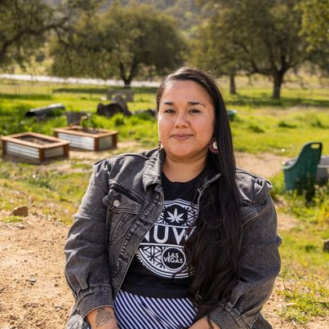

**Emily Burgueno** is an enrolled citizen of the Iipay Nation of Santa Ysabel, which is one of twelve Kumeyaay Bands in Southern California and 6 Kumiai Villages located in Baja CA. She is the Head Seed Keeper for Maat Hetemii, serves as Chairwoman for the Kumeyaay Diegueno Land Conservancy, and Vice Chair for the California Agricultural Land Equity Task Force. (Alternate Bio: Emily Burgueno is the Head Seed Keeper at Maat Hetemii on the Iipay Nation of Santa Ysabel and Chairwoman of Kumeyaay Diegueno Land Conservancy. *Maat Ik'wa'naan na'poom Synaawkwatun kopai. Sha'mulq Paipa na'poom Hilmeup kopai. Turtetch e'chesh sapuur na'poom e'Muht Mo'hey.*)

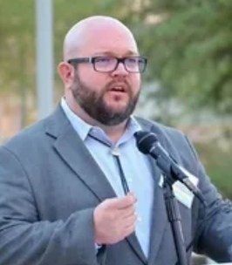

**Robert Przeklasa** has been with the Native American Land Conservancy for over a decade, first as a volunteer, then a board member, and now as executive director. He first became involved through his doctoral studies in tribal history at the University of California, Riverside. His love of the land stretches back to early childhood and he is honored to be doing the work of the Conservancy today.



**Dr. Beth Rose Middleton Manning** (Afro-Caribbean and Eastern European), Prof. of Native American Studies, UC Davis. Her research centers the Indigenous and rural environmental justice impacts of natural resource infrastructure and policy, using environmental laws and processes for protection of cultural places and lifeways, assessing and addressing environmental health impacts, and collaborating on climate adaptation with Native nations and communities. She has published on rural and Indigenous environmental justice, environmental and tribal law, political ecology, and historic and contemporary environmental policy.

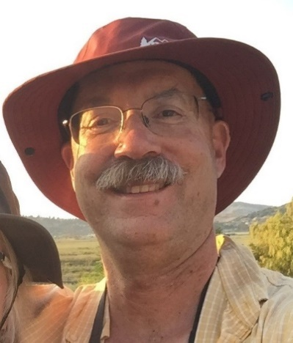

**Bob Neale** is the Land Trust Alliance’s California Senior Program Manager. A life-long Californian, he has lived, worked, and roamed over much of the state. Before coming to the Alliance, Bob spent 19 years as Sonoma Land Trust (SLT)’s Stewardship Director, overseeing the development, expansion, and evolution of their stewardship work. During his tenure at SLT, the stewardship team tripled in size and embraced landscape scale land management, restoration of conservation lands, and wildfire resiliency. On the conservation easement defense front, Bob oversaw a successful enforcement effort that went to the Supreme Court of California. Prior to his time at SLT, Bob worked to simplify the regulatory process for conservation projects at Sustainable Conservation in the San Francisco Bay Area. He began his conservation career at Peninsula Open Space Trust. He loves nature and can often be found walking his dogs Tyger and Ollie or running the trails in Annadel State Park.

**Session 4: Tribal Training Room - Funding Strategies**

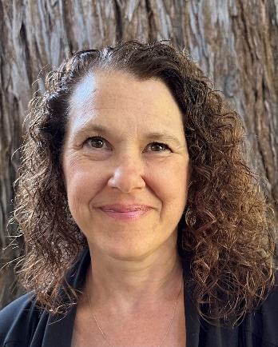

**Karin Winters** is Program Director at the California Council of Land Trusts.  Ms. Winters manages two grant programs developed by CCLT to help move CA Land Trusts onward to further implement 30x30 through capacity building block grants and education. Prior to this position, she was Vice-President and Principal at The Dangermond Group since 2001. Ms. Winters has a Bachelor of Science in Biology from the University of Rochester, a Master of Arts in Forest Ecology from Rice University, and a Masters in Business Administration from the University of California, Davis. Ms. Winters' combination of degrees and experience brings a unique perspective to conservation and planning projects.

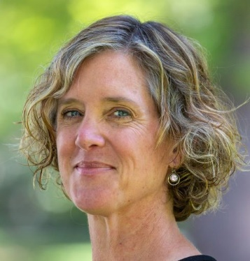

**Jennifer Norris** is the Executive Director of California’s Wildlife Conservation Board. Previously, she served as Deputy Secretary for Biodiversity and Habitat at the California Natural Resources Agency where she led the state’s 30x30 initiative and oversaw “Cutting Green Tape” in support of landscape scale habitat restoration. Jennifer has held numerous positions in federal and state government including supervisor of the Sacramento Office for the United States Fish and Wildlife Service. She has extensive experience in conservation policy, endangered species protection and ecosystem management. She holds a B.S. in Resource Policy and Planning from Cornell University, an M.S. in Conservation Biology from the University of Michigan, and a Ph.D. in Ecology from the University of New Mexico. When she is not at work, she can be found exploring wild beaches, forests, and deserts with her family.

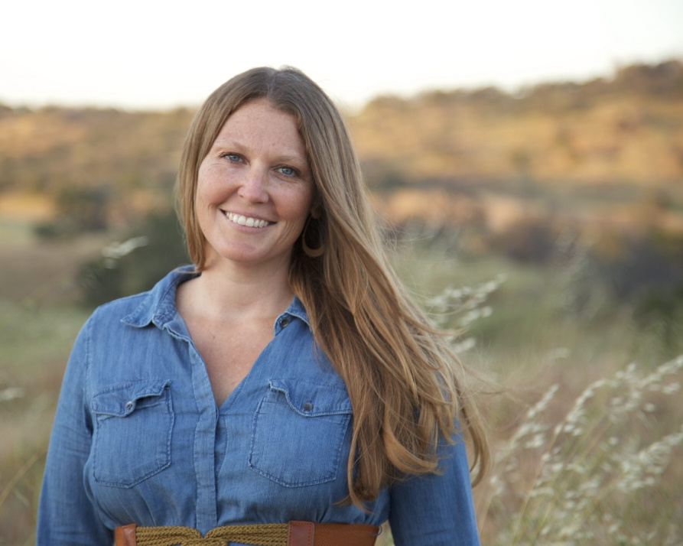

**Bridget Fithian** was born and raised in Mariposa where she developed her love of open spaces. Bridget has worked in land conservation at Sierra Foothill Conservancy since 2009 and in 2015 was selected as SFC’s Executive Director. Since taking over as Executive Director, Fithian has doubled the operating budget of Sierra Foothill Conservancy and expanded land acquisition and engagement programming. She oversees over 64,000 acres of conserved lands specializing in creative solutions to achieve conservation goals and working landscape conservation.

Working with seemingly divergent communities from environmentalists to multi-generational cattle ranchers, to public utility districts, Bridget has helped conserve more than 30,000 acres in the central Sierra. Recent projects have established and expanded Mariposa’s first publicly accessible preserve- adjacent to local schools and protecting the town’s water resource, creating the largest private nature preserve in the Sierra Foothills, connecting 27,000 acres of conserved lands in the San Joaquin River Corridor, and participating in the first Sierra Meadow restoration GHG & carbon sequestration cohort.

Bridget serves as the current board chair for the California Council of Land Trusts, as Board President of the Sierra Cascade Land Trust Council where she founded and chairs the Policy Committee and serves as a liaison to Sacramento on Sierra Nevada issues. She is honored to be a member of the Land Trust Alliance Leadership & Excellence Program. Bridget currently serves as the President and Director of the California Conservation Action Fund.

Bridget is a graduate of UC Santa Cruz. She lives in Mariposa with her husband and two daughters and enjoys a life filled with family and beautiful open spaces.

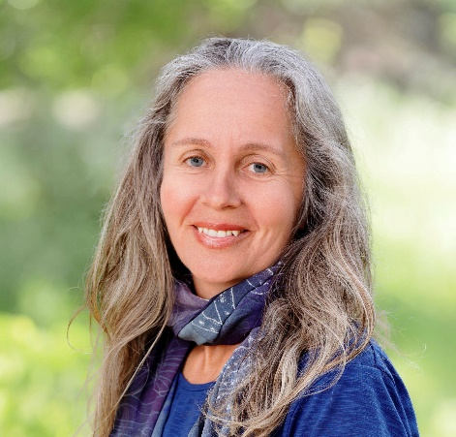

**Kaitilin Gaffney** develops and manages projects for Ocean, Coast, and Fisheries programs. Before joining Resources Legacy Fund, she was the Pacific program director for Ocean Conservancy, managing activities on the West Coast, including ocean governance, fisheries, marine protected areas, and water quality. Kaitilin was a Fulbright Fellow in New Zealand, where she studied fisheries policy and received a Master of Commerce degree from Victoria University in New Zealand. She is a graduate of Berkeley Law, University of California.

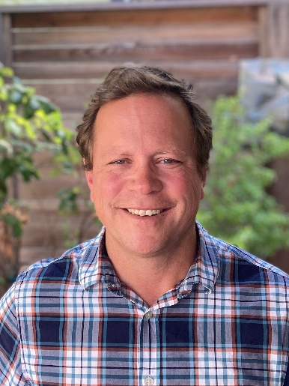

**Keali’i Bright** serves as a Division Director at the Department of Conservation. In this role, he helps regions shape and lead climate resilience strategies for agricultural land, wildfire, and groundwater sustainability. Keali’i has prior experience working at the Natural Resources Agency and the Legislature in multiple natural resources programs and policy areas.

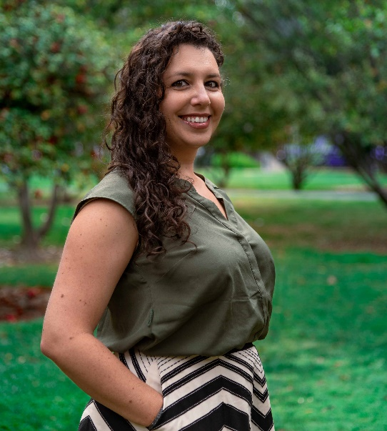

**Shanna Atherton-Bauer** is a Senior Environmental Planner with the Department of Conservation, Division of Land Resource Protection and leads programs related to the conservation of California’s agricultural lands. She has over 10 years of professional experience in the environmental planning, sustainable agriculture, and land conservation fields.

**1:00-2:30**

**Session 3 and 4: Non-Tribal Land Trust Room - Experiences of Meaningful Tribal Partnerships**

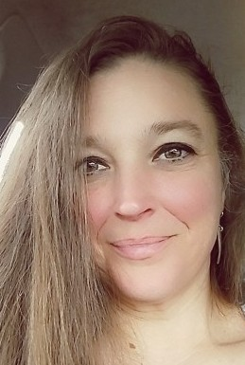

**Merry Kate Droz** (Wyandot~ Anishinaabe), Administrative Assistant, Humboldt State University – Arcata, CA, B.A. Social Sciences Teacher Preparation, Minor Native American Studies, Minor American Indian Education, Multiple Subjects/Single Subject Teaching Credential 2005 I graduated from California Polytechnic Humboldt University Teacher Credential Program and the Indian Teacher and Educational Personnel Program. My first teaching position included participating in creating the American Indian Academy Charter High School located at McKinleyville High school. I taught NAS/Social Sciences, independent study, and was the teacher of record for Yurok Language, for aawok Aileen Figueroa and aawok Kathleen Vigil. In addition to secondary grades, I taught 5th/6th, and then K-3 at the Weitchpec Elementary Yurok Magnet Program, the first part-time Native Language Immersion in a CA public school. As a curriculum/education specialist, I participated in the development of the Indian Land Tenure curriculum aligned with state standards for KTJUSD (K-3) and Save CA Salmon. The SCS Water Advocacy curriculum (9-12th) was recognized by UNESCO Green Citizens and I also was part of the curriculum team for the recently released Traditional Ecological Knowledge curriculum (6-8th) in partnership with Humboldt State University CalPoly Native American Studies department. Curriculum coaching for educators, Native STEAM/TEK presentations for all ages and integrating Native language into daily life. I’m currently working for the Northern CA Tribal Court Coalition, the Tribal Marine Collaborative, and most of all, blessed to be mom for two awesome boys, K’nek’nek’ (14) and Repoy (13).

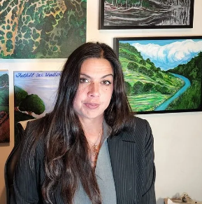

**Ali Meders-Knight** is a dedicated Tribal Seed Bank Manager for the Mechoopda Indian Tribe, overseeing a strategic partnership with the Mendocino National Forest through a 638 Agreement under the authority of the National Forest Protection Act. With over two years of experience teaching Traditional Ecological Knowledge (TEK) as part of the Intertribal Agricultural Council's Tribal Nursery Training Program in collaboration with UC Davis, Ali has been instrumental in bridging traditional practices with contemporary land stewardship. As a Mechoopda Tribal member and Traditional Ecological Knowledge practitioner, Ali is committed to enhancing community resilience through the revitalization of native plants, sustainable traditional land tending, and seed sovereignty. This work includes engaging with multiple stakeholders, including public and private landowners, to foster partnerships in forest stewardship contracting and tribal restoration programs. Ali Meders-Knight, the Executive Director of California Open Lands and a Mechoopda Tribal member, has collaborated extensively in environmental education and land restoration over the past two decades. Based in Chico, CA, Ali is also a traditional basket weaver and mother of five. She has worked closely with organizations such as Chico State University, the City of Chico, and Resource Conservation Districts of Butte and Tehama Counties, among others, to promote sustainable land management practices rooted in Traditional Ecological Knowledge.

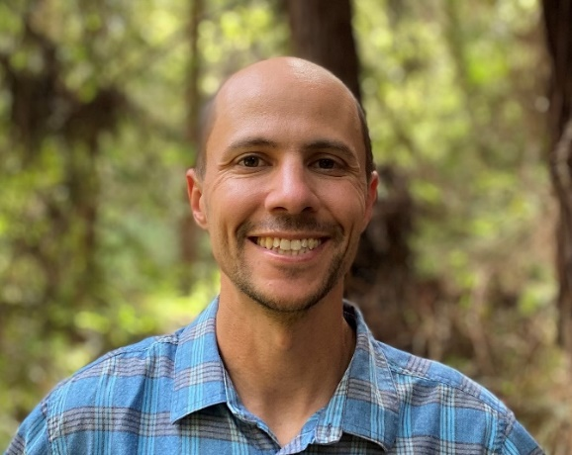

**Ben Blom** is the Director of Stewardship and Restoration for Save the Redwoods League. In this role, Ben leads the League’s work across a broad portfolio of restoration initiatives, partnerships and projects across the ranges of coast redwood and giant sequoia. He also oversees the ongoing stewardship, monitoring and management of the League’s held lands and conservation easements, totaling nearly 50,000 acres across the State of California. Ben hods a Master of Forestry from the Yale School of the Environment.

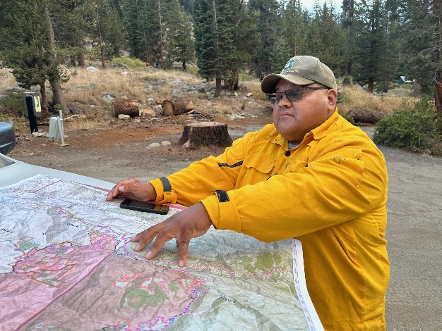

**William Garfield** comes to the Forest Service after serving in tribal government for his community. In 2021 Mr. Garfield served as the Chairman of the Tule River Tribe. Mr. Garfield has also held other roles such as Councilman and Vice Chairman of the Tribal Council. Mr. Garfield has been with the Forest Service for the past year and a half and has the opportunity not only to help his own tribe but to help all other tribes directly engage in all activities the National Forest system has to offer.

The Sequoia National Forest collaborates with 10 tribes and several different tribal organizations that have interest in the forest. Each tribe has their own form of government, culture, and community practices. The position of Tribal Relations Specialist has a responsibility to keep tribes informed on what activities are going on in the forest and ensure that there is a place to have access to water, space to gather traditional foods, and not just to survive but to thrive.

Garfield says, “Since I have been on the forest, I have had the support to make a difference in the lives of many in our tribal communities. Along with specialist from the Sierra and the Inyo National Forests, we have been able to distinguish the tribes to the appropriate forests for a streamlined form of communication. This has allowed us to be more effective because working with Tribal governments calls for a higher level of due diligence to fulfil the United States trust responsibility to tribes”.

“I am truly proud of the support that the Sequoia National Forest has given me to strengthen the tribal relations program. Thanks to the Sequoia National Forest Service team we have increased meeting attendance, gone to the field to support tribal interest projects, elevated tribal projects to forest priority, and we are on the cutting edge of creating new Forest Service Policy for Cultural Burning to support indigenous religious freedom”.

Highlight - In November of 2023 Garfield worked collaboratively with the Tule River Tribe and the United States Forest Service to conduct the first Cultural Burn on the Sequoia National Forest in Over 150 years.

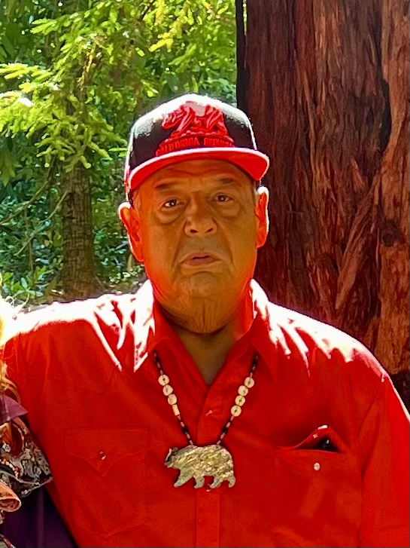

**Chairman Tom Little Bear Nason** has been working on land back issues for the last 30 years. In 2020 The Esselen Tribe received their first Ancestral sacred lands  back  with 1200 acres of Big Sur Coast and Redwoods in. California. As one of the first tribes to get land back in the State of California,

The  Tribe have been working with Big Sur Land trust for several years to preserve over 5,000 additional acres thru a co-management agreement. This has been a major learning curve for both parties. Chairman Nason will explain some of the lessons with the panel alongside Jeannette Tuteli Lewis, Executive Director of Big Sur Land Trust.

The Tribe has also worked with many other land owners and managers such as CA State Parks, Western Rivers Conservancy, Trust for Public Lands and The Wildlands Conservancy to co-manage and preserve over 30,000 acres to date.

~~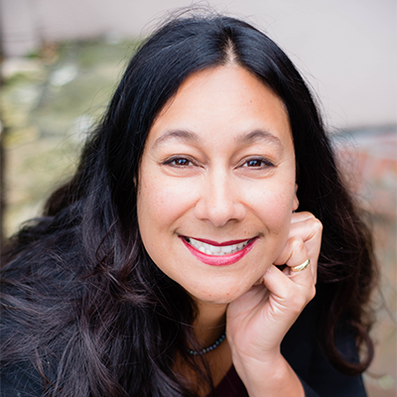~~

**Jeannette Tuitele-Lewis** became BSLT's President and CEO in October of 2014. Under her leadership BSLT has expanded its programs and partnerships with a greater focus on community-centered land-based projects that meet multiple conservation and social benefits.

Prior to coming to BSLT, she worked for Sierra Foothill Conservancy for nine years, serving as executive director for the last five.  During her tenure, the organization doubled its operations, developed working partnerships with tribes, and became Land Trust Alliance accredited.

Born in California, Jeannette split much of her youth between the West Coast and the Pacific Islands. Upon graduating from the University of Hawai'i at Manoa with a botany degree, Jeannette worked in the American Samoan Islands for the Community and Natural Resources Division. There she documented medicinal uses of plants by traditional healers, worked with local farmers, and coordinated restoration efforts with village chiefs.  She received her master's degree in forest science from Oregon State University, where her studies integrated agroforestry systems, land tenure, and traditional ecological knowledge.  Following graduate school, Jeannette worked as a forest science technician, collecting data on carbon storage in old growth forests across the Pacific Northwest.

Jeannette serves on the board of the California Council of Land Trusts and on the national Leadership Council of the Land Trust Alliance.  She also serves on the Peggy and Jack Baskin Foundation board, which supports strategies to reach gender and racial equity.

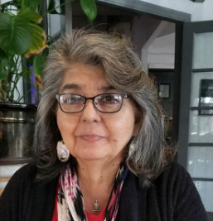

**Louise J. Miranda-Ramirez** was appointed as Tribal Chairwoman in October 2006 and her position confirmed with an election in 2007 officially installed 2008. The Ohlone/Costanoan-Esselen Nation Tribal Council and Chairwoman Miranda-Ramirez received the support of Tribal Membership in 2013 with a vote of continuity as the Government of the Ohlone/Costanoan-Esselen Nation. Louise is the Great Granddaughter of Thomas Santos Miranda and Maria Inez Agnes Garcia Miranda, both Esselen, identified by Special Agent C.E. Kelsey, as the Monterey Band of Monterey Indians at Sur Rancheria, outside of San Carlos Borromeo de Carmelo Mission. The Thomas Santos Miranda family is the only family identified by name as the Monterey Band of Monterey as Special Agent Kelsey identified California Landless Indians in 1906 and later.

Her Mother, Marcelina, Buena Ventura Chumash, said I was born at my Grandmother’s ranch in Pajaro, Monterey County. She was visiting from Santa Barbara. It was raining in November, and she was staying in a tent at the ranch. She said it took quite a while for the ambulance to get to the ranch and I was born before they arrived at the ranch. Unfortunately, My birth certificate reads that I was born at Cottage Hospital, Watsonville, CA, Santa Cruz County and not in my homeland of Monterey County. I’ve lived in Santa Barbara, Monterey, Seaside, King City, Salinas, Stockton, Gilroy, and San Jose, CA.

Chairwoman Miranda-Ramirez works to build Government to Government relationships with Monterey County, the Dept. of Army, FORA, BIA, CSUMB, Board of Education and others. She and other tribal members work to educate students at schools within Monterey County of our continued existence. Our displays can be viewed at the John Steinbeck Library during Native American month in November. Most importantly she works with the Breath of Life Program at the University of Berkeley, to return her Ancestral Language. She opens events in prayer and introductions in her Esselen language. Working with linguist David L. Shaul and notes from A.L. Kroeber, John Peabody Harrington, C.H. Merriam and LePerouse, she works to return stories and prayers in Esselen. She has received grants to provide members with coloring books and language brochures. Her favorite phrase is “Let Ka Lai, Let Ka Lai, Let Cha’a.”

Her most important work is to protect the remains of her Ancestors as they are disturbed in the name of progress and the lack of humanity from those with money.

**3:00-3:30**

**Session 5: Commitment to Action and Partnerships**

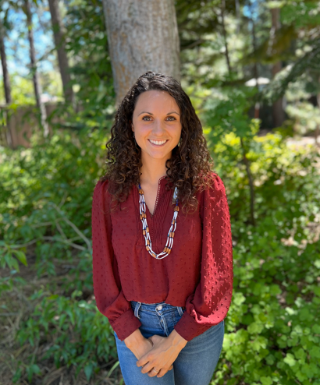

**Taylor Pennewell** is a citizen of the Berry Creek Rancheria of Tyme Maidu Indians, located in Butte County, California. She has a Master in Teaching from the University of San Francisco. Taylor is the Founder and Executive Director of Redbud Resource Group, a Native woman-led non profit organization with the mission to help improve public health outcomes for Native American communities through education, research, and community partnerships.

**3:30-4:45**

**Session 6: Roundtable Discussions**

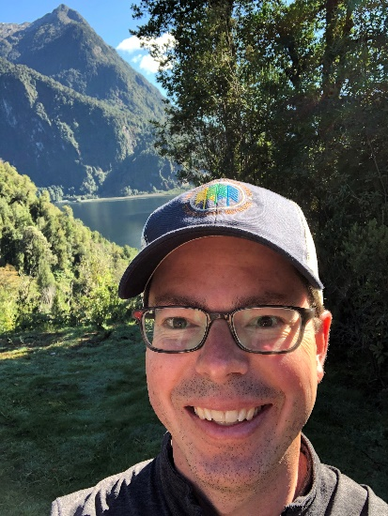

**Shawn Johnson** is Director of the Center for Natural Resources & Environmental Policy at the University of Montana and Co-Chair of the Center’s graduate certificate program in Natural Resources Conflict Resolution. Shawn enjoys working with the Center’s talented team and partners to create spaces to reimagine and make meaningful progress on conflicts, challenges, and opportunities related to a wide range of complex, adaptive natural resource and environmental challenges. Shawn organizes and leads strategic planning and capacity building workshops for a wide variety of organizations focused on natural resource policy and management and has served as a facilitator and mediator on issues ranging from land use planning and forest management to conservation priority setting and regional collaboration.

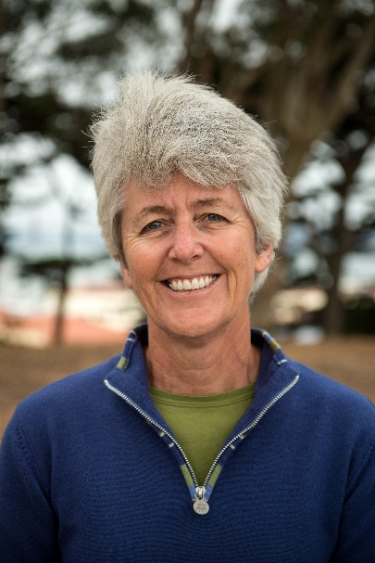

**Sharon Farrell** is a Strategic Advisor with the Stewardship Network and focuses on strategic planning; authentic partnership development, community engagement, governance and sustainability; landscape scale stewardship and conservation, and collaborative capacity projects and programs nationwide. The former Executive Vice President of Projects, Stewardship and Science with the Golden Gate National Parks Conservancy, Ms. Farrell has worked for more than 40 years as an ecologist, park and community planner and project manager. She has a background in vegetation management, restoration ecology, and landscape-scale natural resources planning. Her work scales regional, state and national levels through facilitating collaborative cross-boundary landscape stewardship networks – One Tam in Marin County, the Golden Gate Biosphere Network, the California Landscape Stewardship Network, the Giant Sequoia Lands Coalition, and as a member for the Network for Landscape Conservation.

**5:00pm – End of Workshop**

**5:00-7:00 – Wild and Scenic Film Festival Screening**