Urban Greening Full Proposal Submission in RAPTR
- Applicant logs into RAPTR. Click “Grants” from the top ribbon, then select “Submit Proposal” from the dropdown menu. Click the “Open” button for the 2026 Urban Greening Grant Program. This will open your previously submitted proposal.
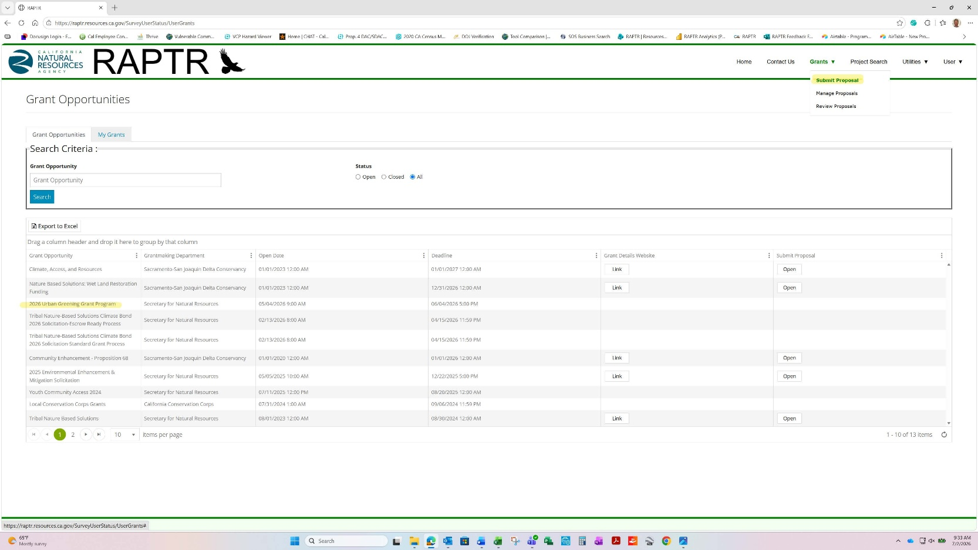

- At the introduction page, you will need to click Step 1 on the left panel. Then, select “I have been invited to proceed to Step 2: Submit Full Proposal (invitation required)” as shown in the yellow highlighted section of the screenshot below. Then, click the “Next/Save” button.
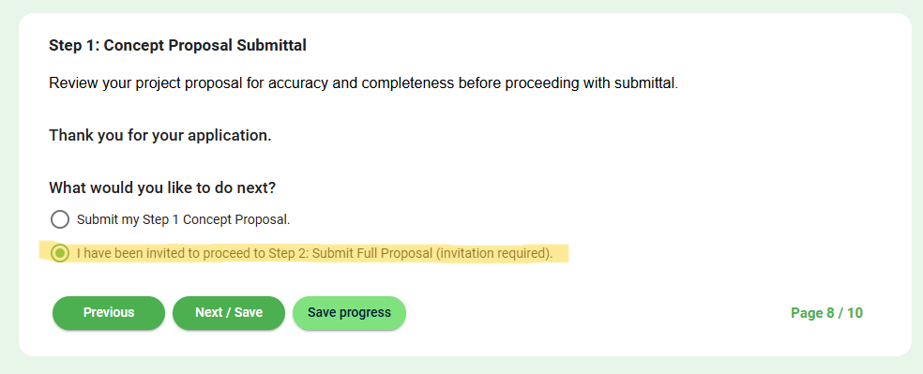

- The following page will open. Upload the completed Full Proposal Form and all required supporting documentation as listed.
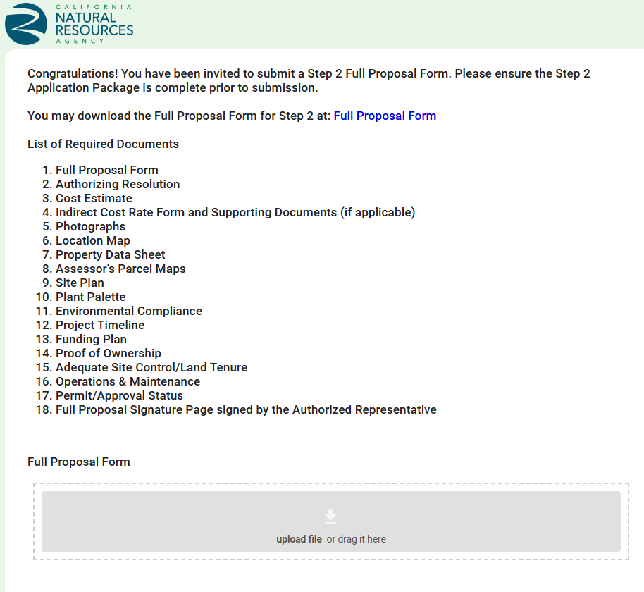
- Once ready to submit, click “Next/Save.” Click “Submit” to sumit your Full Proposal to CNRA. Once submitted, you no longer be able to change your proposal and will see the screenshot shown below:
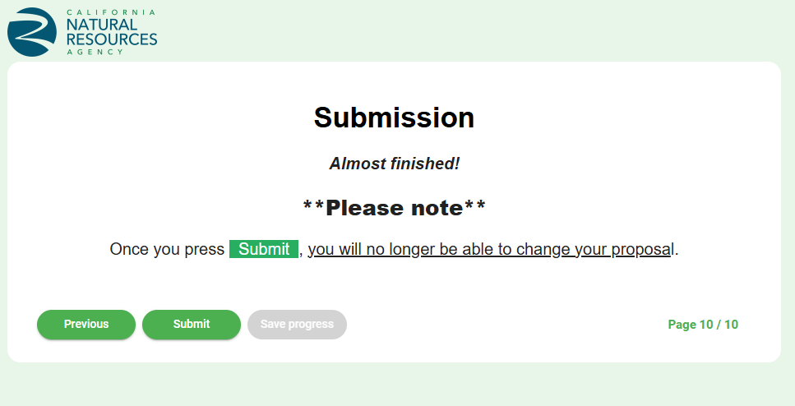
For RAPTR technical assistance, please email raptr@resources.ca.gov.

