APPENDIX H - SIGN GUIDELINES
Types of Signs
- Sign posted during construction
A sign is required during construction. Recommended minimum size of sign: 4.5 feet x 7.5 feet.

- Signs Posted Upon Completion
All Grantees are required to post a sign at the project site. The sign must be available for the final inspection of the Project. There is no minimum or maximum size other than the minimum size for the logo as long as the sign contains the required wording.

Project Title/Description

Another project funded by Proposition 50 through the
California Resources Agency to improve River Parkways
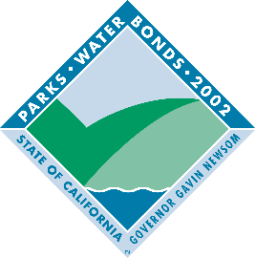

GAVIN NEWSOM, GOVERNOR
Wade Crowfoot, Secretary for Resources

Language for Signs
All signs will contain the following minimum language:
The name of the director of the local agency or other governing body may also be added. The sign may also include the names (and/or logos) of other partners, organizations, individuals and elected representatives.

Logo
All signs must contain a universal logo for the Parks and Water Bond Acts (see above). The logo is available at http://resources.ca.gov/grants/logo-art/.
The logo must be mounted in an area to maximize visibility and durability. Each side of the logo must be a minimum of 2’X2’, but exceptions may be approved when appropriate.

Sign Construction
All materials used shall be durable and resistant to the elements and graffiti. The California Department of Parks and Recreation and California Department of Transportation standards can be used as a guide for gauge of metal, quality of paints used, mounting specifications, etc.

Sign Duration
Project signs must be in place for a minimum of four (4) years.

Sign Cost
The cost of the sign(s) is an eligible project cost. More permanent signage is also encouraged (e.g., bronze memorials mounted in stone at trailheads, on structures, etc.).

Appropriateness of Signs
For projects where the required sign may be out of place or where affected by local sign ordinances, the Grants Administrator in consultation with the Grantee may authorize a sign that is appropriate to the Project in question.

Signs on State Highways
Signs placed within the state highway right-of-way may require a Caltrans encroachment permit. Contact your local Caltrans District Office early in the Planning phases for more information. You can find your local Caltrans District Office by visiting http://www.dot.ca.gov/localoffice.htm.

State Approval
The Grantee shall submit proposed locations, size, number of signs and language for review prior to ordering signs. Funds for Development projects will not be reimbursed until signage has been approved and installed.

