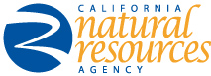

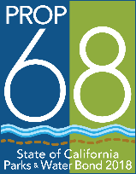 | 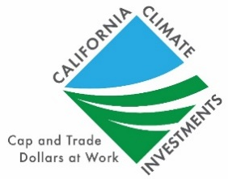 |  | 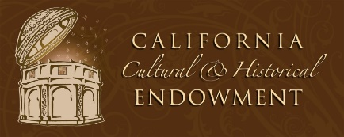

BONDS AND GRANTS UNIT – PROGRAM INFORMATION SHEET

PROPOSITION 68
Green Infrastructure - $18.5M available for green infrastructure projects (e.g., green streets, tree planting, parks, commuter trails, etc.). Competitive to local, nonprofit, nongovernmental land conservation entities, federally recognized Native American tribes, or non-federally recognized California Native American tribes listed on the California Tribal Consultation List. Anticipate release of draft guidelines and meetings for public comments February 2019.
Cultural Community & Natural Resources - $37.0M available for projects that do any of the following 1) restore, protect and acquire Native American, natural, cultural, and historic resources within the state; 2) convert and repurpose properties or parts of properties that served as the site of a fossil fuel powerplant to create permanently protected open space, tourism and park opportunities through fee title or conservation easements; 3) enhance visitor experiences through development, expansion, and improvement of science centers operated by foundations or other nonprofit organizations in heavily urbanized areas; 4) enhance park, water, and natural resource values through improved recreation, tourism, and natural resource investments in areas of the state not within the jurisdiction of a state conservancy, and 5) promote, develop, and improve any of the following: a) community, civic, or athletic venues; b) cultural or visitor centers that recognize the contributions of California’s ethnic communities or celebrate the unique traditions of these communities, including those of Asian and Hispanic descent; c) visitor centers or nonprofit aquariums that educate the public about natural landscapes, aquatic species, or wildlife migratory patterns. Competitive to local, nonprofit, nongovernmental land conservation entities, federally recognized Native American tribes, or non-federally recognized California Native American tribes listed on the California Tribal Consultation List. Solicitation open. Final concept proposal submission February 13, 2019.
Trails & Greenways - $27.7M available for trail projects. Competitive to local agencies, state conservancies, federally recognized Native American tribes, non-federally recognized California Native American tribes listed on the California Tribal Consultation List, joint powers authorities, and nonprofit organizations. Anticipate draft guidelines and public hearings June 2019.
Urban Stormwater & Waterways Improvement - $92.5M available for low-impact, multi benefit projects in urbanized areas to address flooding (e.g., stormwater capture and reuse, restoration of urban streams and watersheds and increasing permeable surfaces to help reduce flooding). Anticipate draft guidelines and public hearings mid-2019.
California Climate Investments (Greenhouse Gas Reduction Fund)
Urban Greening Round 3 - $19.0M available for projects that sequester carbon and/or reduce vehicle miles traveled (e.g., commuter paths, tree plantings, parks). Competitive to city, county, special district, nonprofit, & JPA entities. Solicitation open. Final concept proposal submission February 28, 2019.
ONGOING/ANNUAL PROGRAMS
Environmental, Enhancement & Mitigation (EEM) – $6.7M available for projects that offset negative environmental impacts from transportation projects (e.g., urban forestry, acquisitions to project resource lands). Competitive to state, local, federal & nonprofit entities. Solicitation each April; awards each March.
Museum –$1.0M (estimated/projection) biennially for small museum projects. Competitive to state, local & nonprofit entities. Next solicitation anticipated 2020; awards 2021.

Contact Information:
California Natural Resources Agency
Attn: Bonds & Grants Unit
1416 Ninth Street, Suite 1311
Sacramento, CA 95814
(916) 653-2812
bondsandgrants@resources.ca.gov

