Urban Greening Grant Program
SOAR Application Form Instructions

To print your Urban Greening Grant Program from SOAR, please follow the steps below.

- Log into SOAR and enter your active Urban Greening Application
- On the General Information tab, scroll down to the bottom of the page and select the Preview/Submit button. (NOTE: Clicking this button will not submit your application)
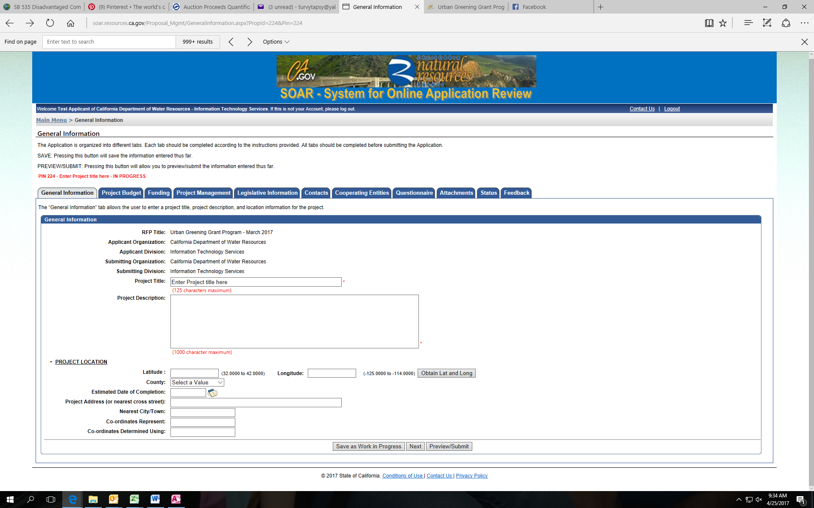

- On the new Application Preview page, select the Print Application button on the top.
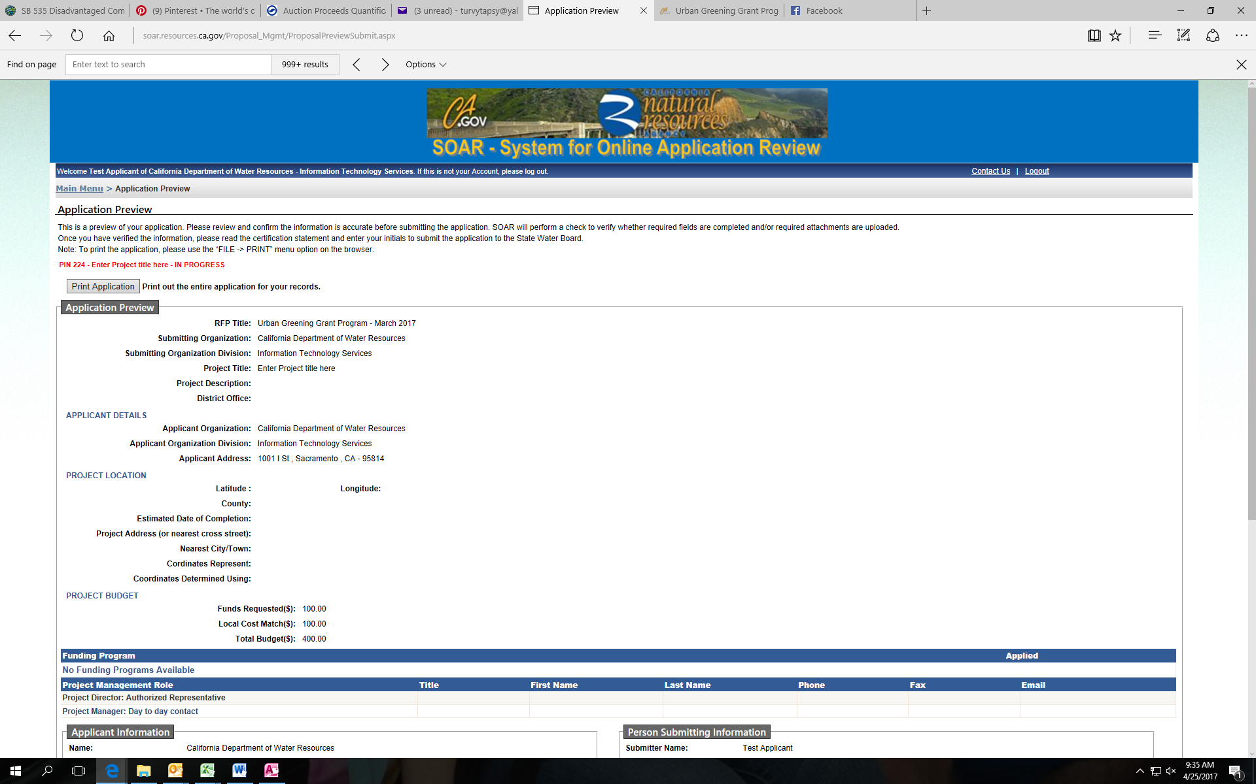
A pop-up box with your application will appear.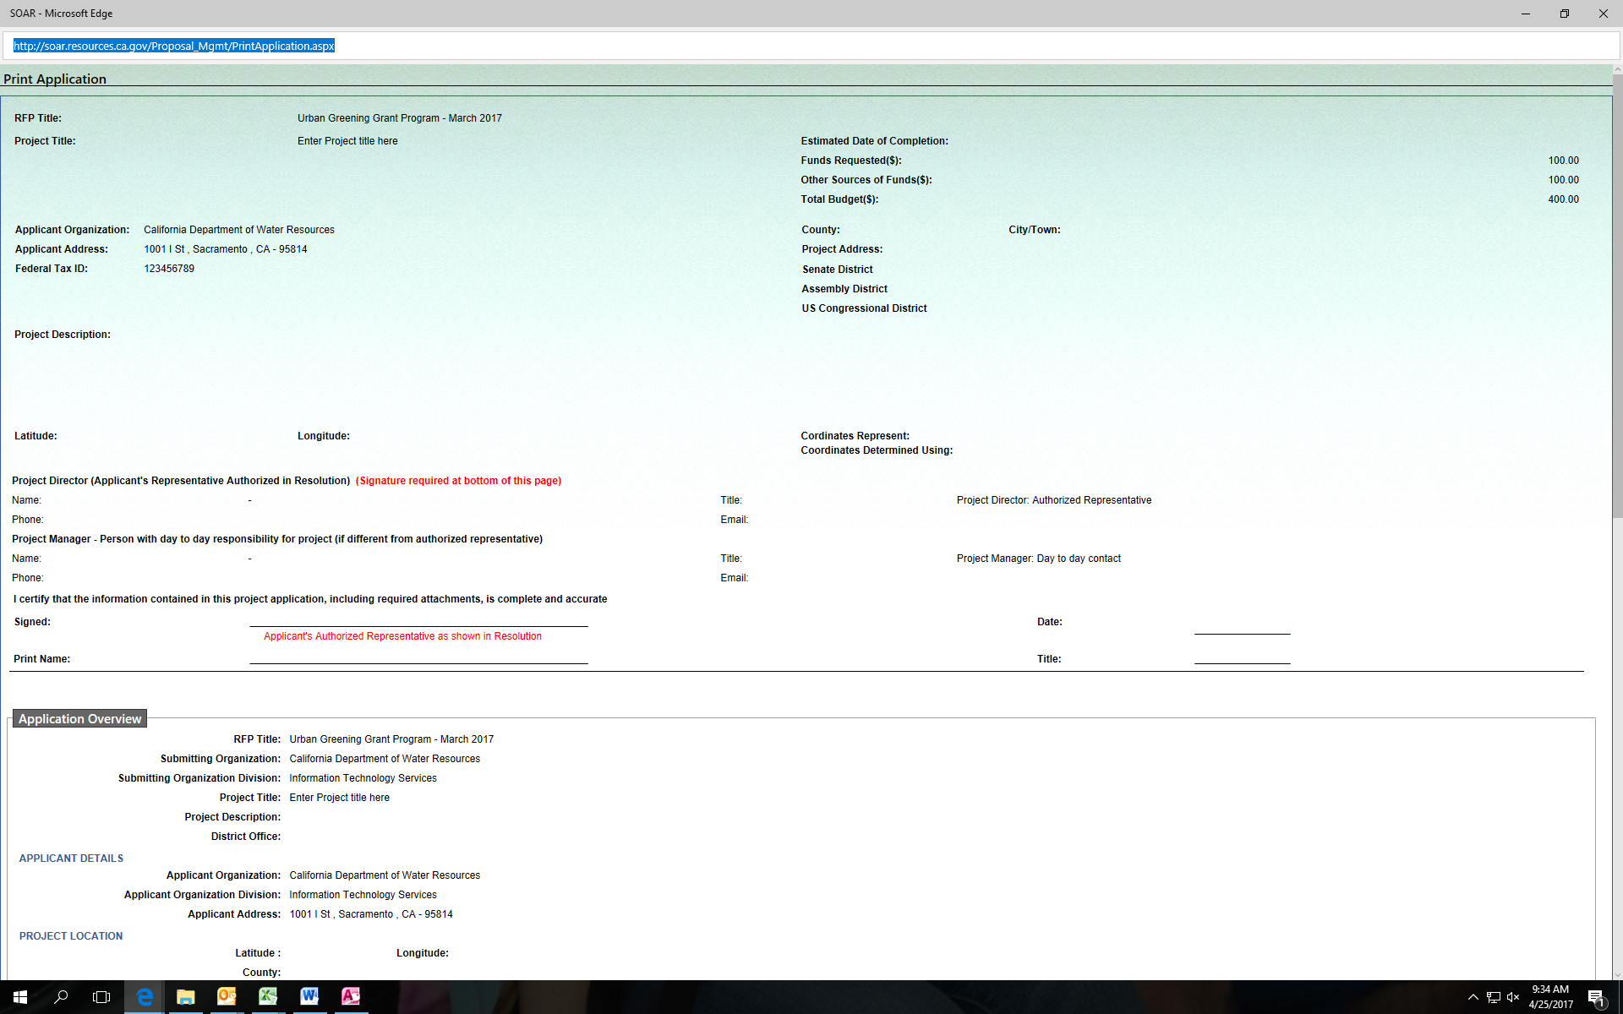
- Select Ctrl+ P, to print the application. Click Print. The first page of the print out is the application form and includes a signature line for the Authorized Representative.

