DRAFT

SIERRA NEVADA-CASCADE CONSERVATION GRANT PROGRAM

FUNDED BY

WATER SECURITY, CLEAN DRINKING WATER,
COASTAL AND BEACH PROTECTION
ACT of 2002

PROPOSITION 50

GRANT GUIDELINES & APPLICATION



STATE OF CALIFORNIA

THE RESOURCES AGENCY

December 2005

Public Comment on these Sierra Nevada-Cascade Conservation Grant Program draft guidelines can be made at http://www.resources.ca.gov/bonds_prop50sncgrantsprogram.html

Public meetings to solicit comments on these draft guidelines will be held as follows:

Wednesday, January 11, 2006
10:00 AM – 12:00 PM
Nevada City- City Hall
317 Broad Street
Nevada City, CA 95959

Thursday, January 12, 2006
10:00 AM – 12:00 PM
City of Susanville – City Council Chambers
66 North Lassen Street
Susanville, CA 96130

Tuesday, January 24, 2006
10:00 AM – 12:00 PM
City of Bishop – White Mountain Research Station - South Classroom
3000 East Line Street
Bishop, CA 93514

All comments must be received by 4:00 PM on January 31, 2006

Please send comments to:

The Resources Agency
Attn: Bonds and Grants Unit
1416 Ninth Street, Suite 1311
Sacramento, CA 95814

Email: snc50@resources.ca.gov

TABLE OF CONTENTS
I. INTRODUCTION 1
Eligible Applicants 1
Statutory Requirements 1
Progam Geographic Area 2
Application Timeframe 2
Contact Information 3
II. EXAMPLES OF INELIGIBLE ACQUISITIONS 3
III. GRANT SELECTION PROCESS 3
IV. EVALUATION CRITERIA 4
V. PREPARING YOUR GRANT APPLICATION 4
VI. PROJECT PROPOSAL NARRATIVE 4
A. Statutory Purposes and Acquisition Benefits 5
B. Statewide Resource Priorities 8
C. Project Readiness 9
D. Organizational Capacity 10
E. Other Sources of Funds 10
VII. LONG TERM MANAGEMENT PROPOSAL 10
VIII. WHAT TO SUBMIT: REQUIREMENTS FOR A COMPLETE APPLICATION 11
IX. PROJECT ADMINISTRATION 14
General Overview of Grant Process 14
Eligible Costs 14
Payment of Grant Funds 14
Periodic Updates and Site Visits 14
Loss of Funding 14
X. STATE AUDIT AND ACCOUNTING REQUIREMENTS 15
XI. APPENDICES 16
APPENDIX A– CITATION FROM IMPLEMENTING STATUTE 16
APPENDIX B– MAP OF GEOGRAPHIC AREA OF PROGRAM 17
APPENDIX C– CALFED SOLUTION AREA AND SIERRA NEVADA CONSERVANCY 18
APPENDIX D– DISADVANTAGED COMMUNITIES 19
APPENDIX E– APPLICATION FORM 23
APPENDIX F– INFORMATION FORM FOR LAND ACQUISITIONS 25
APPENDIX G– LAND USE INFORMATION 27
APPENDIX H– RESOLUTION TEMPLATE 28
APPENDIX I – CERTIFICATION LETTER TEMPLATE 29
APPENDIX J – COMPLIANCE WITH CEQA 30
APPENDIX K– SIGN GUIDELINES 31
APPENDIX L– APPLICATION CHECK LIST 32
APPENDIX M– DEFINITIONS 33

I. INTRODUCTION

- California voters passed the Water Security, Clean Drinking Water, Coastal and Beach Protection Act of 2002 (Proposition 50) on November 5, 2002. Proposition 50 added Section 79544 to the California Water Code, authorizing the Legislature to appropriate $30 million for the acquisition of land and water rights to protect water quality in lakes, reservoirs, rivers, streams and wetlands in the Sierra Nevada-Cascade Mountain Region.

- Chapter 240, Statutes of 2003, imposed specific requirements on state agencies implementing Proposition 50.

- Chapter 230, Statutes of 2004, created the Sierra Nevada-Cascade Conservation Grant Program (Program) within the Office of the Secretary for Resources (See Appendix A). These guidelines establish the process used by the State to solicit applications, evaluate proposals and award grants under this competitive grant program.

Note: Some of the capitalized words in the document have specific meanings (See Appendix M).

Eligible Applicants

Grant funds will be awarded to local public agencies, local public water districts and Nonprofit Organizations.

Statutory Requirements

The Program will provide funding for the acquisition of land and water rights to protect water quality in lakes, reservoirs, rivers, streams and wetlands in the Sierra Nevada-Cascade Mountain Region.

Funds will be awarded for the following types of Acquisitions:

- Working Landscapes – Acquiring agricultural, forest, or grazing land, or other working landscapes, to prevent conversion of that land to uses that could decrease water quality in the region and degrade habitat values, or to convert that land to uses that could improve water quality in the region and habitat.
- Adjacent Lands - Acquiring land adjacent to or affecting rivers, streams, lakes, or wetlands, that, if not protected, could lead to a decrease in water quality in the region.
- Water Rights - Purchasing water rights that will protect both water quality and in stream flow, in the region, for resource protection.
- Management Practices - Acquiring land that mitigates or prevents current or anticipated management practices that contribute to water quality degradation in the region.

Other statutory requirements include:

- Applications must include a proposal for the long-term management of the resource acquired.
- Acquisitions must comply with the California Environmental Quality Act (CEQA), Division 13 (commencing with Section 21000).
- All real property shall be acquired from a willing seller (Public Resources Code, Section 5819.6).
- Additional requirements must be met if the Acquisition is located in CALFED’s solution area (See Appendix C).

Program Geographic Area

Proposition 50 defined the geographic area for the Sierra Nevada-Cascade Conservation Grant Program pursuant to Section 5096.347 of the Public Resources Code. This area includes portions of the following counties located in the mountains, foothills, and the area adjacent to the geologic formations of the Sierra Nevada and the Cascade mountain ranges (See Appendix B for map).

Alpine Amador Butte Calaveras El Dorado Fresno Inyo Kern
Lassen Madera Mariposa Merced Modoc Mono Nevada Placer Plumas Sacramento Shasta Sierra Siskiyou Stanislaus Tehama Tulare Tuolumne Yuba

- The region is defined as the areas bounded on the east by the California Nevada border south from the Oregon border to its intersection with the crest of the White/Inyo Ranges.

- It continues south along that mountain crest to its intersection with State Highway 190, then southwest along Highway 190 to its intersection with Highway 395 at Olancha.

- The boundary continues south on Highway 395 to the intersection of Highway 14, then south along Highway 14 to the intersection with the Sierra Nevada Ecological Unit (EU) [as defined by the US Forest Service map California Vegetation by WHR Classification, August 1994] continuing to its junction with Highway 58.

- The boundary continues along Highway 58 west to its intersection with Sierra Nevada EU.

- It follows north along the western boundary of that EU to its intersection with the western boundary of the Cascade EU.

- It continues north along the western boundary of the Cascade EU to the Pit River arm of Shasta Lake, west to the junction of Interstate 5.

- The boundary continues north along Interstate 5 to the Oregon border and east along the California Oregon border line.

Note: Communities bisected by the boundaries described are eligible for this program.

Application Timeframe

Applications will be solicited after these guidelines are adopted. To receive the program solicitation notice, please send your contact information to the web address below.

The application period is 45 days. Applications must be received at the Resources Agency on or before the date indicated in the solicitation notice. Deadlines will also be posted on the website at:

http://www.resources.ca.gov/bonds_prop50sncgrantsprogram.html

Contact Information

Direct all inquires, correspondence and grant applications to:

Sierra Nevada-Cascade Conservation Grant Program – Proposition 50
The Resources Agency
Attn: Bonds and Grants Unit
1416 Ninth Street, Room 1311
Sacramento, CA 95814
Telephone: (916) 653-5656
FAX: (916) 653-8102
Email: snc50@resources.ca.gov

II. EXAMPLES OF INELIGIBLE ACQUISITIONS

The examples below DO NOT meet statutory requirements and will not be funded under this program - not a complete list.

- Any Acquisition required as mitigation under CEQA, or a required restoration under a state or federal enforcement action
- Acquisitions purchased at more than Fair Market Value as determined by the Department of General Services or another designated authority, even if the cost over Fair Market Value is covered with non-State funds
- Acquisition of parks
- Acquisition of open space buffers required for mitigation
- Acquisitions that will result in a net loss of habitat value for listed, threatened, or endangered species
- Acquisitions that will continue to be at a high risk of disturbance or degradation.
- Acquisitions with little to no habitat value
- Water rights acquisitions that propose the sale of water after the intended water quality and/or in stream flow goals have been met
- Water rights acquisitions that provide a water source for development
- Acquisition of a partial water right

III. GRANT SELECTION PROCESS

- Applicants submit a complete grant application to the State by the deadline.
- Application reviewed for completeness and eligibility.
- Incomplete or ineligible applications will not be evaluated or considered for funding.
- Complete, eligible applications evaluated by the “Sierra Nevada-Cascade Conservation Grant Committee” (Committee), using the Evaluation Criteria.
- In evaluating applications, Committee may consider awarding partial funding.
- Site visits scheduled for semi-finalists. Scores may be adjusted as a result of the site visit.
- The Committee recommends Acquisitions for funding to the Secretary for Resources.
- The Secretary determines the final Acquisition awards.

IV. EVALUATION CRITERIA

Acquisitions will be evaluated using the following values for each criterion: (100 points possible)

- Statutory Purposes and Acquisition Benefits | 50 points
- Statewide Resource Priorities | 20 points
- Project Readiness | 15 points
- Organizational Capacity | 10 points
- Other Sources of Funds | 5 points

V. PREPARING YOUR GRANT APPLICATION

NOTE: Since there are multiple ways of describing property (i.e., identifying by previous owner, ranch name, etc.), the property identifiers used throughout the application package should be consistent.

The Grant Application has four sections:

- Acquisition Overview – Provide a brief description (maximum one page) of the proposed acquisition and its scope, including:
- Assessor Parcel Number(s) of the property(ies) to be acquired
- Location of all parcels
- Number of acres or volume of water involved
- Current land use (e.g. irrigated row crops, dry land grazing, vineyards, orchards, etc.)
- Statement of the water quality problem or need
- Proposed changes and/or uses after the acquisition is complete

- Project Proposal Narrative – The Project Proposal Narrative should respond to the questions listed in Section VI (maximum eight pages).

- Long-Term Management Proposal – Provide a proposal to manage and operate the property acquired with grant funds in a manner consistent with the water quality improvement goals of the Program. See Section VII for a list of questions.

- Supporting Documents – See “What to Submit” (Section VIII) for a detailed list of required Supporting Documents.

VI. PROJECT PROPOSAL NARRATIVE

The Project Proposal Narrative is the basis for the Committee’s evaluation. It provides details on the Acquisition and should demonstrate to the Committee how effectively the Acquisition will meet the requirements of the Sierra Nevada-Cascade Conservation Grant Program.

Respond to all questions in Sections A-E in order and clearly label each answer.
- Limit the Project Proposal Narrative to eight numbered pages.
- Use 8 ½” x 11” paper, with 12-point easy to read font.
- The Acquisition Overview and the Supporting Documents listed in Section VIII
DO NOT count as part of the eight page maximum for the project proposal narrative.

Note: Points will be attributed to each section and not to individual questions. If a question does not apply to your acquisition, indicate “Not Applicable.”

A. Statutory Purposes and Acquisition Benefits (50 points)

Every Acquisition must meet at least one of the four Statutory Purposes. Address each of the questions listed under the purpose that applies to your Acquisition.
Statutory Purpose 1: Working Landscapes

Acquiring agricultural, forest, grazing land, or other working landscapes, to prevent conversion of that land to uses that could decrease water quality in the region and degrade habitat values, or to convert that land to uses that could improve water quality in the region and habitat.

1) Describe the proposed acquisition, including:

- Total acreage of the acquisition
- Type of working landscape
- Percentage of total acreage used as working landscape
- Size and type of affected water body (e.g., creek, stream, river, lake, pond, etc.)
- Type of water usage
- Environmental concerns (e.g., toxins, endangered species habitat, etc.)
- Improvements on the property (e.g., houses, stables, wells, irrigation systems, etc.)
- Affected watershed, and where the property is situated within the watershed

2) Describe the current habitat and water quality conditions.

3) What species use the terrestrial and/or aquatic habitats present on the property for all or a portion of their life cycle?

4) Why is immediate acquisition necessary for resource protection at this site (as opposed to some alternative action)?

5) For acquisitions to prevent conversion of the land to uses that could decrease water quality and degrade habitat:

a) Describe the direct threats to the land that currently exist or are anticipated, (e.g., zoning and/or zoning changes, pending offers, recent regional trends). Provide evidence supporting existing or anticipated threats.

b) How will this acquisition prevent a decrease in water quality and degradation of habitat?

c) Describe how land is being used in the area immediately surrounding the proposed acquisition. How will land use practices in the surrounding area support and/or hinder the goals of the acquisition?

6) For acquisitions to convert land to uses that will improve water quality and habitat:

a) What are the potential conversion and/or restoration opportunities for the area? What species and/or habitats will be affected?

b) What stewardship practices will be implemented to protect the working landscape and/or promote the conservation goals of the proposed acquisition?

c) Describe how land is being used in the area immediately surrounding the proposed acquisition. How will land use practices in the surrounding area support and/or hinder the goals of this acquisition?

Statutory Purpose 2: Adjacent Lands

Acquiring land adjacent to or affecting rivers, streams, lakes, or wetlands, that, if not protected, could lead to a decrease in water quality in the region.

1) Describe the proposed acquisition, including:

- Total acreage of the Acquisition
- Current land use
- Environmental concerns (e.g., toxins, endangered species habitat, etc.)
- Size and type of affected water body (e.g., creek, stream, river, lake, pond, etc.)
- Improvements on the property (e.g., houses, stables, wells, irrigation systems, etc.)
- Affected watershed, and where the property is situated within the watershed

2) What are the current water quality conditions of the water body located adjacent to, or affected by, the subject parcel(s)?

3) How will the proposed acquisition prevent a decrease in water quality in the region?

4) Why is immediate acquisition necessary for resource protection at this site (as opposed to some alternative action)?

Statutory Purpose 3: Water Rights

Purchasing water rights that will protect both water quality and in stream flow, in the region, for resource protection.

Acquisitions of water rights in this program must be designed and executed without injuring any legal user of water, and without unreasonably affecting fish, wildlife, or other in stream beneficial uses, and without unreasonably affecting the overall economy and/or the environment.

1) Describe the water body associated with this water right, including its location, current water quality and in-stream flow.

2) What has been the historic use of this water right? What is the current use of the water right?

3) What is the purpose of this acquisition? What will be protected? Describe the local and regional impacts of the acquisition.

4) What type of water right is to be acquired? If priority has been established, provide evidence. Is the stream/basin adjudicated? If so, provide the adjudication.

5) What quantity of water (expressed in acre feet) or flow of water (expressed in cubic feet per second) is associated with the purchase of this water right? What has been the average consumptive use of the water over the last five years? What method for determining the quantity or amount of flow available was used? (Describe how this quantification takes into account seasonal fluctuations, etc.)

6) How will the purchase of this water right protect both water quality and in-stream flow? What method(s) will you use to sustain this benefit?

7) Who are the current owners of the water right? Provide evidence that demonstrates the current owners’ right to sell (i.e., fee title appropriated or adjudicated water ownership title, deed or other document that demonstrates the validity of ownership) and willingness to sell.
- Documentation must include when water may be diverted, the rate (or amount) of diversion by month, and any conditions in the license.

8) What is the value of this water right? What is the basis for this valuation?

9) Indicate how many parties will be involved in the transaction and describe their respective roles.

10) How will the owners’ water needs be met after the sale of these water rights?

11) What claims or disputes, if any, are associated with this water right?

Note: The Resources Agency reserves the right to request additional information or supplemental documentation as needed to substantiate the goals and the value of the proposed water rights acquisition.

For questions regarding water rights acquisitions specifically, please contact Dean Reynolds, Department of Water Resources at (916) 651-7055 or via e-mail at dreynold@water.ca.gov.

Statutory Purpose 4: Management Practices

Acquiring land that mitigates or prevents current or anticipated management practices that contribute to water quality degradation in the region.

1) Describe the proposed acquisition including:

- Total acreage of the acquisition
- Current land use
- Environmental concerns (e.g., toxins, endangered species habitat, etc.)
- Management practices used on the land
- Size and type of affected water body (e.g., creek, stream, river, lake, pond, etc.)
- Improvements on the property (e.g., houses, stables, wells, irrigation systems, etc.)
- Affected watershed, and where the property is situated within the watershed

2) What are the current water quality conditions?

3) Why is immediate acquisition necessary for resource protection at this site (as opposed to some alternative action)?

4) For acquisitions to mitigate current management practices:

a) What are the current management practices in place that affect water quality?

b) What is the impact of these practices on the affected water body?

c) What is planned to improve or stabilize the affected watershed?

d) Describe how land is being used in the area immediately surrounding the proposed acquisition. How will land use practices in the surrounding area support and/or hinder the goals of this acquisition?

5) For acquisitions to prevent anticipated management practices:

a) What is the anticipated management practice that this acquisition will prevent?

b) Explain how the anticipated management practices would affect the water body.

c) What stewardship practices will be implemented to protect and/or promote the conservation goals of the proposed acquisition?

d) Describe how land is being used in the area immediately surrounding the proposed acquisition. How will land use practices in the surrounding area support and/or hinder the goals of this acquisition?

- Statewide Resource Priorities (20 points)

The State will evaluate Acquisitions by considering factors including, but not limited to, multiple agency collaboration, watershed plan implementation, state water quality priorities, and the geographic distribution of bond funds. Respond to the following questions and describe, where applicable, how your Acquisition addresses these and other statewide resource priorities.

  - Collaboration with Agencies and Other Interested Parties

Describe coordination among affected landowners, local governments, and non-profit organizations concerning this proposed Acquisition as well as other local land conservation activities.

  - Land Use

Is the Acquisition consistent with state, regional or local plans?

Is the Acquisition consistent with state priorities for water quality protection?
(Click on the following link to view state water quality priorities: http://www.waterboards.ca.gov/funding/cg_feedback.html#priorities)

3. Public Benefit

Why should this particular Acquisition be funded?

If the title of the land is changing from private to public ownership, what benefits will the public derive from the Acquisition?

Describe support for the proposed project (i.e., citizen involvement, donated land or materials, volunteer labor, and any outside funds).

4. Multiple Environmental Benefits (e.g., wildlife habitat, recreation and other secondary benefits)

Does the project provide other environmental benefits, outside of the specific water quality goals required for this program?

- Project Readiness (15 points)

To be considered for funding, Acquisitions must be ready to proceed and be completed before the timeframes for the current funding expire.

- Indicate the parties involved in this transaction, their roles, and whether any party other than the Applicant owns an option to buy the real property in question.
- Address the status for each of the following:
- CEQA compliance
- Commitments from project partners
- Comparable sales data
- Appraisal
- Preliminary title report
- Property restrictions and/or encumbrances, easements, mineral rights
- Negotiations of terms of sale, option to purchase or easement with a willing seller.
- How did you determine the best vehicle for the Acquisition (i.e., fee simple, easement, etc.)?
4. Has a Phase I or Phase II Toxic Report been done? If so, briefly describe the findings.
5. What other factors affect the Acquisition's timeline and completion? How will these factors be addressed?
6. Has there been any opposition to the Acquisition? If so, explain the nature of the concerns and how you have addressed them.

D. Organizational Capacity (10 points)

Applicants must demonstrate their ability to complete the Acquisition and manage the acquired resource.

- Describe your experience in completing this type of Acquisition.
- Is the expertise needed to complete your Acquisition readily available within your organization? If not, how do you plan to acquire it? Will you be using experts who are appropriately licensed according to state law?
- Identify the entity that will hold title to the resource, including any state or federal agency to which title may be transferred after Acquisition.

E. Other Sources of Funds (5 points)

Funding from other sources is not required to receive a grant. However, Acquisitions that include Other Sources of Funds will be more competitive. Both monetary and In-Kind support may be considered Other Sources of Funds.

- Identify the source and amount of funds already committed to the purchase and maintenance of the Acquisition and the expected timing of those funds. Cite specific dollar amounts for cash contributions, In-Kind services, volunteer effort, technical expertise, etc.
- If no funding is received from Other Sources, will the requested grant amount be sufficient to complete the Acquisition? Explain.

Disadvantaged Communities
Projects assisting a Disadvantaged Community will receive full points in this category, even if no Other Sources of Funds have been secured.

- Describe the Disadvantaged Community and the basis for concluding the Community is Disadvantaged. (See Appendix D for tools to determine if your Community meets the definition of Disadvantaged.)
- Is the property to be acquired located in the Disadvantaged Community?
- How does the Acquisition benefit the Community?
- In what way did members of the Disadvantaged Community participate in this project?

VII. LONG TERM MANAGEMENT PROPOSAL

Properties acquired with grant funds must be maintained to protect the value of the resource, in accordance with Appendix G, Land Use Information. The Long Term Management Proposal must also support the goals of the Project as presented in the Project Proposal Narrative.

- Describe the long-term management (e.g., weed control, mosquito abatement, fencing, etc.) of the resource:

  - What is planned for the long-term management?

  - Who will perform the long-term management? Describe their experience in managing this type of resource.

  - How will the ongoing management be funded?

- What, if any, future modifications/improvements are planned for the resource (e.g., habitat improvement/restoration, recreation, public access, etc.)? How will the property continue to meet the program requirements with these improvements?

- For Conservation Easements, describe your plan for perpetual stewardship and address ongoing funding to support the terms and conditions of the stewardship plan.

- For Water Rights Acquisitions, how will you preserve the long-term value of the resource?

VIII. WHAT TO SUBMIT: REQUIREMENTS FOR A COMPLETE APPLICATION

The Grant Application is composed of four (4) sections: Acquisition Overview, Project Proposal Narrative, Long Term Management Proposal and Supporting Documents. Materials should be presented in the order indicated below and in Appendix L. Clearly number and label each item and number all pages in sequential order. Do not submit additional materials that have not been specifically requested (i.e., letters of support, press clippings or brochures) as they will not be considered during the evaluation.

NOTE: Several maps are required as part of the application. Make sure to provide directional orientation and indicate any connections between parcels on each map.

Submit one (1) unbound original and six (6) copies of items 1-7:

- Completed Application Form (See Appendix E)
- Acquisition Overview
- Project Proposal Narrative
- Long Term Management Proposal
- LAND ACQUISITIONS – Please provide the following:

  - Information Form for Land Acquisitions – (See Appendix F)
  - Location Map – Directional map, with enough detail to allow a person unfamiliar with the area to locate the Acquisition. Include a Thomas Brothers Guide map if Acquisition is in an urban area. Include other maps or aerial photographs that demonstrate the location and need for the Acquisition. Streets and other notable landmarks should be clearly marked to allow easy identification. Maps or images must fit into an 8½” X 11” binder.

  - Assessor’s Parcel Map – Obtain copies of the map(s) of the subject parcel(s) from the County Assessor’s Office. Applicant must list the complete Assessor’s Parcel Number (APN) for each Project parcel represented on the map submitted (List or label APNs in the corner or other available space on the map). For each APN listed, clearly indicate the boundaries of the parcel.

NOTE: When submitting final proposal application package, all copies of the Assessor’s Parcel Map(s), whether “original” or additional required copies, must be marked as described above.

  - USGS 1:24,000 Scale Quad Map – Indicate the boundaries of the Project on the map.

  - Natural Features Map – Clearly identify on a map of the property: creeks, seeps, springs, ponds, lakes, habitats, water course crossings, diversions, proposed management areas, slides, unstable areas, structures, soil types and any archeological sites.

  - Site Drawing or Map – Include specific details of the property as described in the grant application, including exterior boundaries, access points, types of land use areas (residential, commercial, retail), proposed location of required acknowledgement and any interpretive signage, agricultural use and location, roads, mines, wells, hazardous sites, trails, maintained fence lines, etc. Indicate the location of any existing buildings and/or impediments (storm drains, power lines, etc.).

  - Legal Description of Property – This can be obtained from recorded deeds, title reports, etc. Include the Assessor’s Parcel Number(s) associated with each description.

  - Restrictions/Encumbrances – Copies of any Easements, mineral rights, Williamson Act Contract or other conditions that may affect the proposed parcel.

  - Photographs – Provide up to five (5) labeled color photographs of different views of the property to be acquired reflecting current conditions at the site. Color photocopies are also acceptable. Pictures should be no larger than 8 ½ by 11 inches.

NOTE: When submitting final proposal application package, all copies of the photographs, whether “original” or additional required copies, must be submitted in color.

- Water Rights Acquisitions – Please provide the following:

  - Water Right Application Number
  - Recent copy of Water Permit and/or License
  - Copies of any Orders to Change, if applicable
  - Recent copy of Report of Permittee or Report of Licensee, whichever is applicable.
  - Documentation of non-appropriative water right ownership including deeds, title, lease, etc., if applicable

- Timeline – Provide estimated timeline for all tasks associated with the Acquisition. The timeline must demonstrate that the Acquisition will be completed before the timeframes for the current funding expire.

Submit one (1) unbound original and two (2) copies of items 8-18:

- Signed Authorizing Resolution from Governing Body
- See Appendix H for required Resolution format and content.
- For agencies without a governing board, see Appendix I for Certification Letter from Chief Executive Officer.

- Purchase Option – If available, provide copies of the purchase option for this Acquisition.
- Evidence of Willing Seller – Provide letter(s) from current owner(s) indicating they are a willing participant(s) in the proposed property transaction. Each letter must clearly indicate that should grant funds be awarded, seller is willing to enter into an agreement for the sale of the property and for a purchase price not to exceed Fair Market Value.

- Evidence of Local Support – If the Applicant is not a public agency, provide a letter of support from the applicable local jurisdiction.

- Proof of Compliance with CEQA – See Appendix J for eligible submissions.

- Operations & Maintenance Agreements – If operations and maintenance will be performed by another entity, explain and provide evidence of concurrence from that entity, such as operational agreements, Letters of Intent, Memoranda of Understanding or Memoranda of Agreement signed by all parties.
- Other Sources of Funds – List all Other Sources of Funds appearing on the Information Form for Land Acquisitions. Include cash contributions, In-Kind services, volunteer efforts, technical expertise, etc. Cite specific dollar amounts and the percentages of the total funding provided from all sources. Indicate if funds have been committed or requested; provide evidence of funds committed, including copies of award letters or other written documents.

- Evidence of Eligibility for Nonprofit Applicants – Provide evidence that
- Corporation is qualified under Section 501(c) (3) of the Internal Revenue Service Code
AND
- Formed pursuant to the Nonprofit Public Benefit Corporation Law (Division 2, commencing with Section 5000, of Title 1 of the Corporations Code).

- Disadvantaged Community – Provide documentation to support Disadvantaged Community determination (See Appendix D).

- Local Water District Applicants – Local water districts should provide evidence of their district type and statutory authority.

- Sierra Nevada Conservancy – If Acquisition is within the boundaries of the Sierra Nevada Conservancy (Conservancy) (see http://www.sierranevadaconservancy.ca.gov/location.html for map), submit a brief narrative that details how the project will help further the mission and goals of the Conservancy (see http://www.sierranevadaconservancy.ca.gov/docs/ab2600.pdf for goals and mission).

IX. PROJECT ADMINISTRATION

General Overview of Grant Process

- Secretary for Resources awards grants.
- State sends Grant Agreement and materials for grant administration to Grantee.
- Grantee signs and returns all required copies back to the State (a fully executed copy will be returned to the Grantee).
- Grantee submits appraisal and other transaction documents.
- State conducts appraisal and transaction document review.
- Grantee requests State deposit Funds into escrow.
- Grantee posts signs acknowledging source of Funds (See Appendix K).
- State makes final inspection and approves final payment.
- The grant may be audited as frequently as necessary during the course of the project and for three years after the acquisition is completed.

Eligible Costs

Only direct Acquisition-related costs incurred during the Project Performance Period specified in the Grant Agreement will be eligible for funding. All eligible costs must be supported by appropriate documentation. Indirect Costs are not eligible.

NOTE: The State will not participate in an Acquisition where the purchase price is more than Fair Market Value, as defined by the Department of General Services or other designated authority.

Payment of Grant Funds

Funds cannot be disbursed until a Grant Agreement between the State and the Grantee is fully executed.
- Up to 90 percent (90%) of the State approved purchase price may be advanced into an escrow account within 60 days of close of escrow.
- The remainder of the grant funds shall be available on a reimbursable basis.
- Ten percent (10%) of the grant amount will be withheld until all closing documents have been received, signs installed and a project close-out site visit has been completed.

Periodic Updates and Site Visits

The State may request periodic written updates on progress and perform site visits to determine if the project is consistent with the approved Project Scope and ensure compliance with the signage requirements.

Loss of Funding

The following are examples of actions that may result in a Grantee’s loss of funding (not a complete list):
- Grantee fails to obtain a Grant Agreement.
- Grantee withdraws from the grant program.
- Grantee fails to submit all documentation within the time periods specified in the Grant Agreement.
- Grantee fails to submit evidence of CEQA compliance within one year as specified by the Grant Agreement.
- Grantee changes Project Scope.
- Grantee fails to substantially comply with terms of the Grant Agreement.
- Property cannot be acquired at approved Fair Market Value (FMV), even if non-State funds are used to supplement the difference between FMV and the price of the property.
- Grantee fails to complete funded Project.

If grant Funds were advanced, those Funds, plus any accrued interest, must be returned to the State.

X. STATE AUDIT AND ACCOUNTING REQUIREMENTS

Audit Requirements

Projects are subject to audit by the State of California and for three (3) years following the final payment of grant Funds. If your Project is selected for audit, you will be contacted in advance. The audit shall include all books, papers, accounts, documents, or other records of the Grantee, as they relate to the Project for which the Funds were granted.

The Grantee must have the Project records, including the source documents and canceled checks, readily available, and provide an employee with knowledge of the Project to assist the auditor. The Grantee must provide a copy of any document, paper, record, or the like, requested by the auditor.

Accounting Requirements

The Grantee must maintain an accounting system that:

- Accurately reflects fiscal transactions, with the necessary controls and safeguards,
- Provides a good audit trail, including original source documents such as purchase orders, receipts, progress payments, invoices, time cards, canceled checks, etc.
- Provides accounting data so the total cost of each individual Project can be readily determined.

Records Retention

Project records and source documents must be retained for a period of three (3) years after final payment is made by the State. All Project records and source documents must be retained by the Grantee at least one (1) additional year following an audit. A Project is considered complete upon receipt of final grant payment from the State.

XI. APPENDICES

APPENDIX A – CITATION FROM IMPLEMENTING STATUTE

SIERRA NEVADA-CASCADE CONSERVATION GRANT PROGRAM
CHAPTER 230, STATUTES OF 2004
Definitions
5819. Public Resources Code
Unless the context requires otherwise, the following definitions govern this chapter:
(a) "Acquisition" means obtaining fee title or a lesser interest in real property, including an easement, development right, or water right.
(b) "Development" includes, but is not limited to, improvement, rehabilitation, restoration, enhancement, preservation, protection, and interpretation.
(c) "Interpretation" includes, but is not limited to, visitor serving amenities that communicate the significance and value of natural, historical, and cultural resources in a manner that increases understanding of those resources.
(d) "Nonprofit organization" means a private, nonprofit organization that qualifies for exempt status under paragraph (3) of subsection (c) Section 501 of Title 26 of the United States Code.
(e) "Program" means the Sierra Nevada-Cascade Conservation Grant Program established pursuant to this chapter.
(f) "Secretary" means the Secretary of the Resources Agency.
(g) "Sierra Nevada-Cascade Mountain Region" or "region" has the meaning set forth in subdivision (e) of Section 5096.347.

Program Parameters
5819.4. Public Resources Code
To implement Section 79544 of the Water Code, the secretary may provide grants to local public agencies, local water districts, and nonprofit organizations, for acquisition in the region pursuant to this chapter and consistent with Section 79544 of the Water Code, only for the following purposes:
(a) Acquiring agricultural, forest, or grazing land, or other working landscapes, to prevent conversion of that land to uses that could decrease water quality in the region and degrade habitat values, or to convert that land to uses that could improve water quality in the region and habitat.
(b) Acquiring land adjacent to or affecting rivers, streams, lakes, or wetlands, that, if not protected, could lead to a decrease in water quality in the region.
(c) Purchasing water rights that will protect both water quality and in stream flow, in the region, for resource protection.
(d) Acquiring land that mitigates or prevents current or anticipated management practices that contribute to water quality degradation in the region.
5819.5.
The secretary shall require an applicant for a grant for land or water resource acquisition to include in the grant application a proposal for the long-term management of the resource that the applicant proposes to acquire. The applicant shall identify the entity that will hold title to the resource, including any state or federal agency to which title may be transferred after acquisition, and the entity that will be responsible for managing and protecting the water quality value of the resource.
5819.6.
An acquisition made pursuant to this chapter shall be from a willing seller.
5819.7.
All regulations, criteria, and procedural guides that the secretary adopts to implement this chapter are exempt from Chapter 3.5 (commencing with Section 11340) of Part 1 of Division 3 of Title 2 of the Government Code.
5819.8.
It is the intent of the Legislature to provide in any legislation that establishes a Sierra Nevada Conservancy an appropriate transition from the program established by this chapter within the Resources Agency to the new conservancy.

APPENDIX B – MAP OF GEOGRAPHIC AREA OF PROGRAM
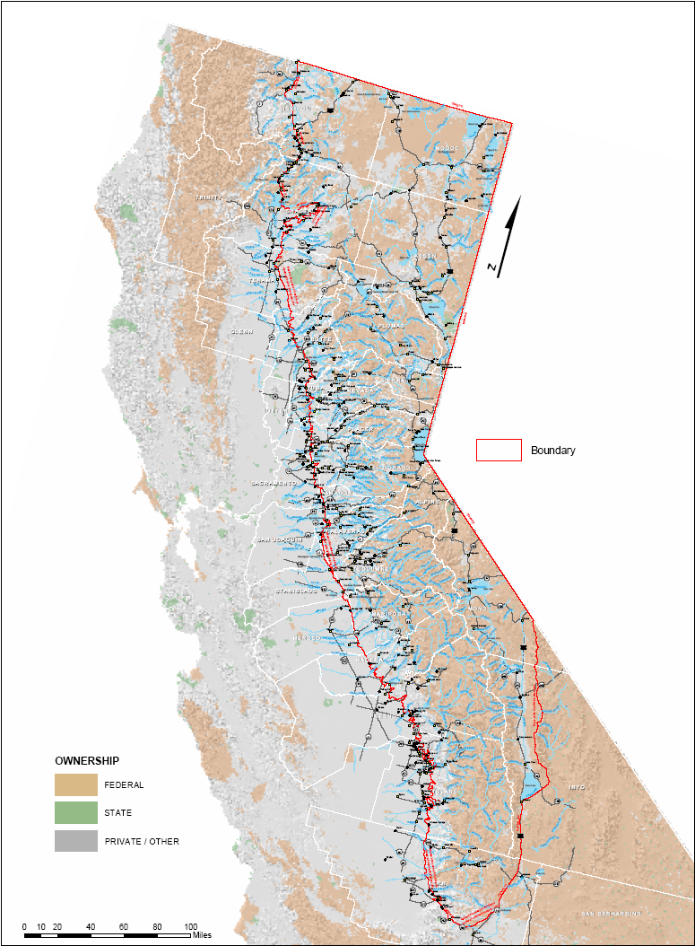

Copies of this map are available in Adobe Acrobat format in two levels of detail @ http://resources.ca.gov/bond/grantmap50.pdf and http://resources.ca.gov/bond/MAP072401c.pdf.

APPENDIX C – CALFED SOLUTION AREA AND SIERRA NEVADA CONSERVANCY
CALFED SOLUTION AREA

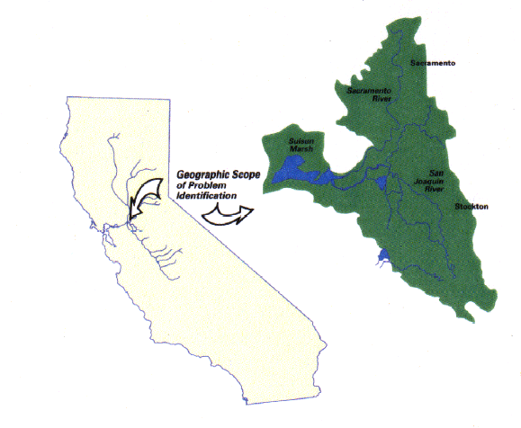
The CALFED program addresses problems that have been identified in or
closely linked to the Suisun Bay/Suisun Marsh and Delta area (see map).
However, the scope of possible solutions to these problems encompass
any action that can be implemented by the CALFED agencies, or can be
influenced by them, to address the identified problems-regardless
of whether implementation takes place in the Delta/Suisun Bay/
Suisun Marsh area. The
solution scope is quite
broad, potentially
including any action that
could help solve identified
problems in the Bay Delta.
The solution area is broad
because many problems
related to the Bay-Delta are
caused by factors outside the
Bay-Delta (Final Programmatic
EIS/EIR – July 2000).
(http://calwater.ca.gov/CALFEDDocuments/Final_EIS_EIR.shtml)

Water Code Sections 79509 and 79509.6
provide the California Bay-Delta Authority with
the opportunity to review and comment on Projects
located in the CALFED solution area to determine whether
or not the Project is consistent with the CALFED Programmatic
Record of Decision (ROD). In addition, these sections require,
to the extent possible, that Projects that assist in the fulfillment of the goals of the CALFED Bay-Delta Program be implemented through local and regional programs. The State will consult with the Bay-Delta Authority to ensure that Projects in the solution area are consistent with these requirements.

SIERRA NEVADA CONSERVANCY

If Acquisition is within the boundaries of the Sierra Nevada Conservancy (Conservancy) (see http://www.sierranevadaconservancy.ca.gov/location.html for map), applicants will need to submit a brief narrative that details how the project will help further the mission and goals of the Conservancy (see http://www.sierranevadaconservancy.ca.gov/docs/ab2600.pdf for goals and mission).

APPENDIX D – DISADVANTAGED COMMUNITIES

Applicants are allowed to use whatever tools they have to access and use 2000 census data to determine Disadvantaged Community status. The procedures and suggestions presented here are to assist Applicants. These procedures are not mandatory and will not receive preference over any other method.

A Disadvantaged Community is a Community with a population of persons residing in the same locality under the same local governance such as a city, town, county, or named unincorporated area that has a median household income of less than eighty percent (80%) of the statewide annual median household income.

To determine if your Acquisition is located within or serves a Disadvantaged Community, the following questions should be addressed:
- What communities are located within the Project area?
- Does the Acquisition serve any communities located adjacent to or outside of the Project area?
- Do any of the communities located within the Project area (or immediately adjacent to it) have a median household income of less than $37,994?

Applicants may use Census Designated Place (CDP) to define their Community. Remember, your Acquisition must be primarily or substantially WITHIN the geographic boundary of the Disadvantaged Community.

Accessing Census Data for Project Area:

The following information provides tools available on the Census 2000 website to help define your Project in terms of CDPs and the median household income for those CDPs.

If your organization has GIS capability, you can access shape files for different census geographies including CDPs at http://www.census.gov/geo/www/cob/bdy_files.html. Using GIS tools, the Project area and the CDP shape files can be layered to determine what CDPs (if any) exist in the defined Project area.

Another way to determine CDPs within the Project area is to use the mapping feature at the 2000 Census website: http://factfinder.census.gov/home/saff/main.html?_lang=en

The following is a step-by-step description of how to use the mapping feature:

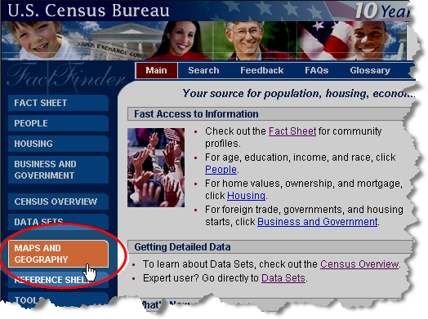

1. From the main page, click on “Geography and Maps”:

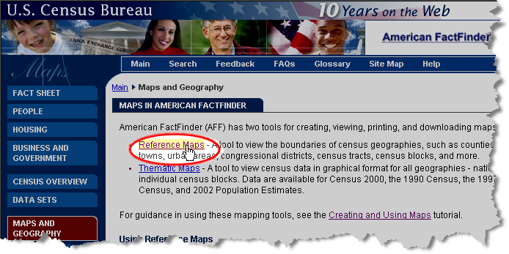

2. Select “Reference Maps”. Click on the national map in the general area where the Project is located.

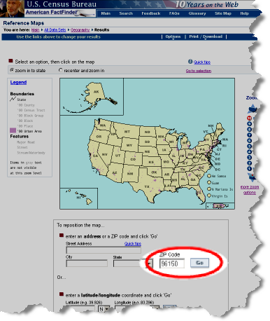

3. Continue to zoom into the map until the Project area can be distinguished or enter a specific address, zip code or latitude and longitude coordinates that further differentiate and identify the Project area.

In this example, the zip code for South Lake Tahoe has been entered:

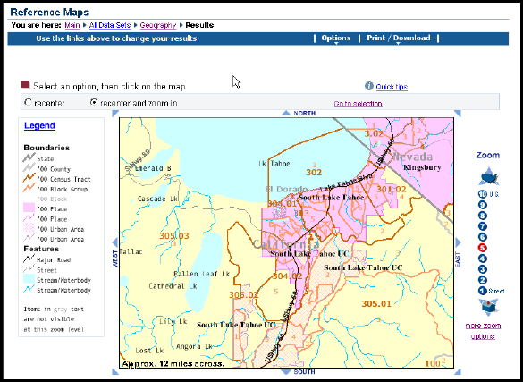

After entering the South Lake Tahoe zip code and clicking on “Go”, a regional map is created. The CDPs within the specified region are shown in pink.

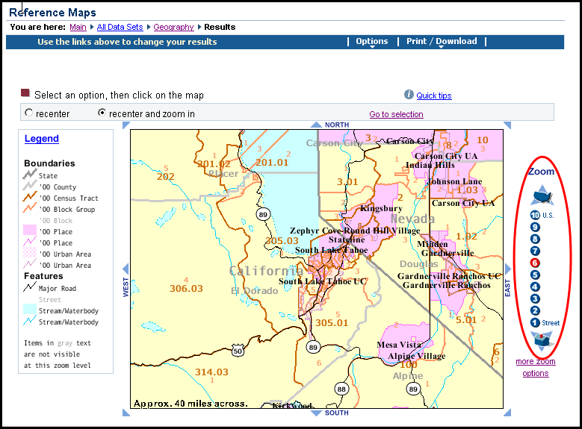

4. Use the zoom buttons to the right of the map window to decrease or increase the scale of the region and places being viewed.

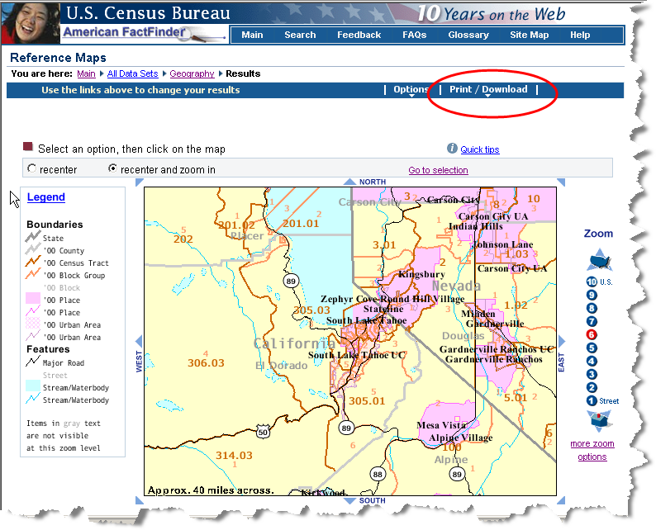

5. When the map is scaled appropriately for purposes of defining the Project area, click on Print/Download” on the menu bar

Obtaining Median Household Income (MHI) Data:
To determine if any of the census Places within your Project area meet the definition of Disadvantaged Communities, the median household income of the CDP needs to be determined. This data can be obtained from the Census web page at http://factfinder.census.gov/home/saff/main.html?_lang=en
The following is a step-by-step description of how to use the MHI identification tools:

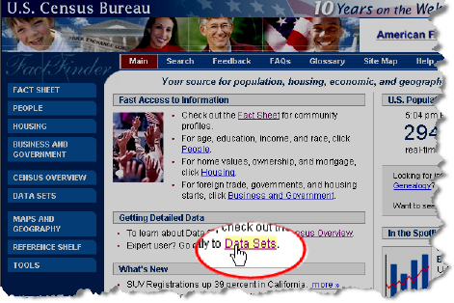

1. From the Census home page, Select Data Sets under the section entitled “Getting Detailed Data”:

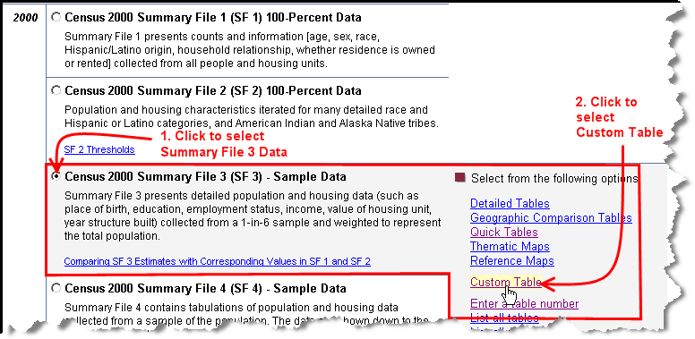

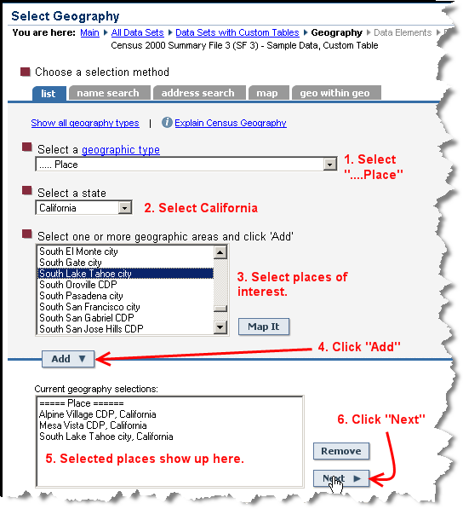
2. Select “Census 2000 Summary File 3” and Click on “Custom Table”:

3. “Select Geography” is the next window. Select “list” as the selection method. Under “Select a geographic type”, use the pull down menu to select “place”. Under “Select a state”, highlight “California” from the pull down menu. The last box allows a selection of one or more Places. Use the pull down menu to highlight the name of a “geographic area” in your Project area and click “Add”. Repeat this step for each additional “geographic area” located in the Project area. All the “geographic areas” that have been highlighted should be shown in a list in the section titled “Current geography selections”. Click “Next” to continue.
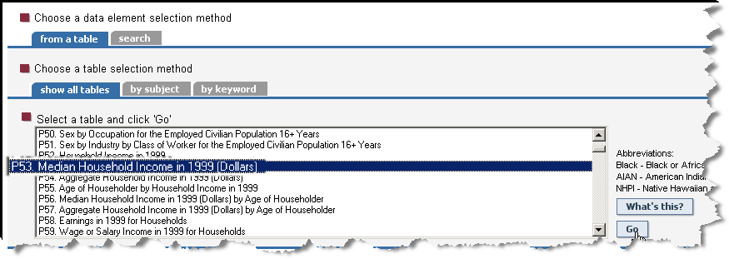

4. On the next page, the “data element selection method” and the “table selection method” default to the correct setting. Under “Select a table”, highlight “P53. Median Household Income in 1999 (Dollars)” then click “Go”:

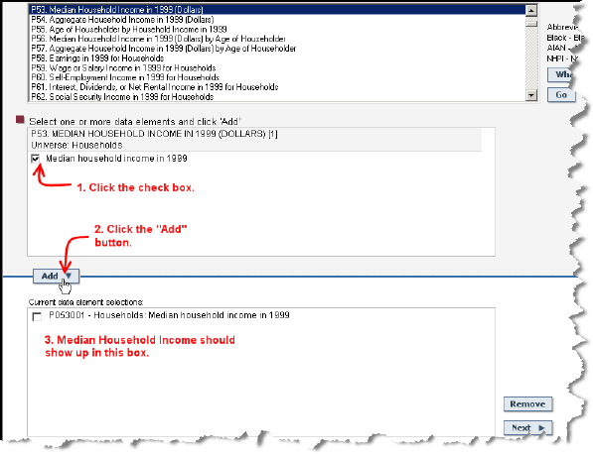

5. By clicking the “Go” button, the data selected populates the window entitled “Select one or more data elements and click “Add.” To confirm the data set selected, click on the checkbox to the left of the data set selected. Then scroll down and click on the “Add” button.

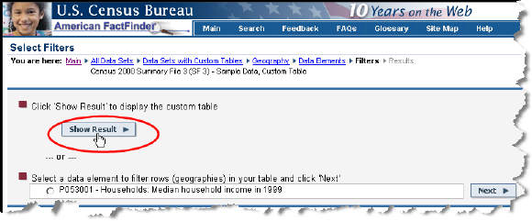

6. Click “Next”. On the next page, click “Show Result”.

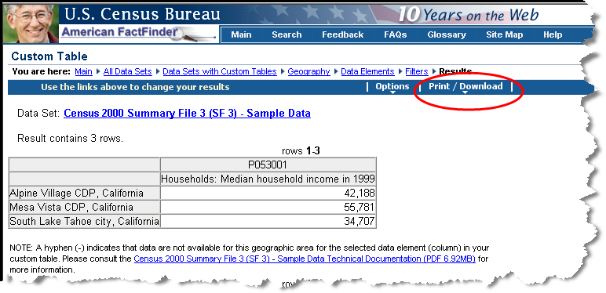

7. The table shown should contain the median household income for each of the CDPs you selected. You can print this table or download it as a Microsoft Excel spreadsheet by selecting “Print/Download” from the top of the page.

8. Include a copy of the spreadsheet in your application to support your Disadvantaged Community determination.

APPENDIX E – APPLICATION FORM

State of California - The Resources Agency
Water Security, Clean Drinking Water, Coastal and
Beach Protection Act of 2002 – Proposition 50
Sierra Nevada-Cascade Conservation Grant Program

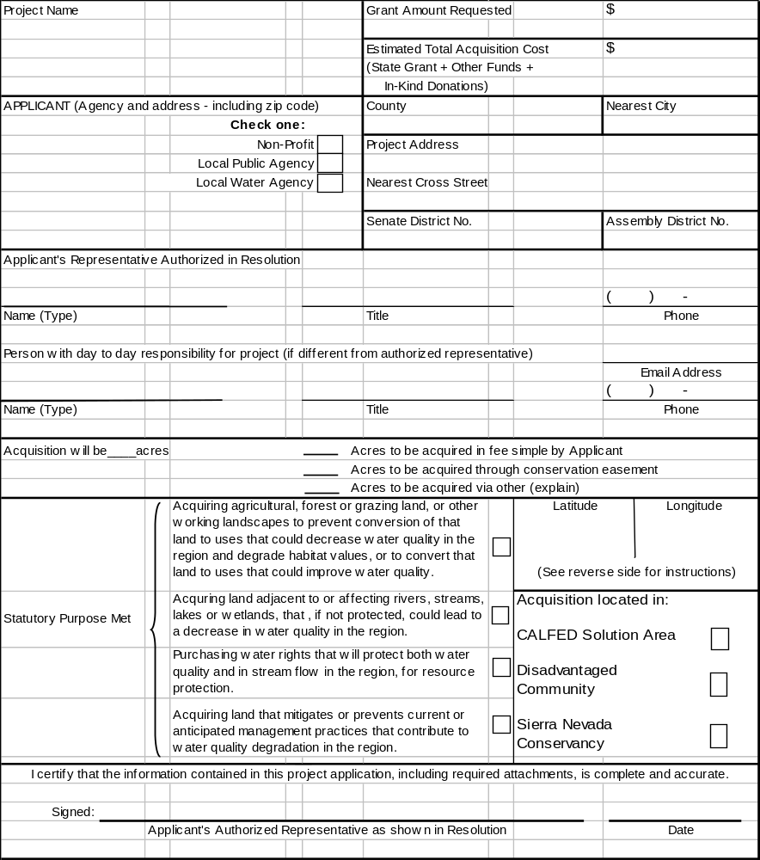
Latitude/Longitude (Degrees/Minutes/Seconds)

The application must include the coordinates of the general center point of your Project. This information can be obtained using the Internet at www.topozone.com as follows:

- Enter the location (city/county/township, etc.) of your Project and “California” under “Place Name Search” ---- a map of the general area will be displayed.

- Click on location (city/county/township, etc.) ---- if more than one location appears, click appropriate one.

- Put cursor on your specific Project site location and click ---- the map will zoom in on the new location moving the red target symbol to the correct location. You can enlarge the MAP by clicking on the upper frame of the map on either 1:25,000 or 1:50,000 (1:100,000 will take you back to the initial resolution and 1:200,000 will allow you to zoom out further).

- Once you have found the location of your Project, scroll down and under “Coordinates”, click on “D/M/S” (degrees, minutes, and seconds) ---- the information will then be displayed at the TOP of the map.

- If multiple sites are proposed for acquisition, include coordinates for each non-contiguous parcel.

If you have any difficulty with Topozone, or need help locating your Project, you can contact the Resources Agency, CERES Program at (916) 654-9990, or e-mail Ray McDowell at ray@ceres.ca.gov.

APPENDIX F – INFORMATION FORM FOR LAND ACQUISITIONS

Water Security, Clean Drinking Water, Coastal and
Beach Protection Act of 2002 – Proposition 50
Sierra Nevada-Cascade Conservation Grant Program
(Please complete one form for each separate escrow - See instructions on reverse)

Project Title:

Assessor’s Parcel Number(s) | Acreage | Indicate fee or Easement | Willing Seller Name and Address
ACQUISITION COST ESTIMATE
 | Total Costs | Sierra Nevada-Cascade Grant | Other Sources of Funds  (specify by name)
1. Estimated Fair Market Value of property
2. Relocation Costs
3. Preliminary Title Reports, Appraisal

4. Escrow Fees, Title Insurance, Closing Costs
5. Surveying (limited to boundary line adjustment)
6. Direct Staff and Consultant Costs (limited to $10,000 per grant)

7. Costs for State Approval of Appraisal, Transaction Review etc.
(use $10,000 per escrow)

8. Required Signage

9. Contingency (Not to exceed 10%)
Grand Total

Information Form for Land Acquisitions – Instructions

Only direct Acquisition-related costs incurred during the Project Performance Period specified in the Grant Agreement will be eligible for funding. All eligible costs must be supported by appropriate documentation. Indirect Costs are not eligible.

Please complete a separate form for each escrow.

Provide full Assessor’s Parcel Number, acreage and type of title to be acquired for each parcel in this escrow.

Acquisition Cost Estimate:

- Estimated Fair Market Value of Property – Provide estimated Fair Market Value for the property. If more space is needed, provide detail on each parcel on a separate sheet.

- Relocation Costs – Provide a parcel-by-parcel analysis of the extent of the relocation assistance required by the State Relocation Act [Chapter 16 (commencing with Section 7260) of Division 7 of Title 1 of the Government Code]. Attach additional pages as needed. Include at a minimum:

  - The number of persons/businesses displaced.
  - The types of displaced entities (families, small retail businesses, large wholesale or manufacturing enterprise, farms, churches, hospitals, etc.).
  - The tenure (month-to-month rent, long-term lease, or fee title) of the displaced entities.
  - Any special problems inherent in relocating the displaced entities (lack of adequate replacement housing, large inventory of merchandise to be moved, or unique quality of the enterprise that may make duplication at any other location difficult).

3 - 6. Costs of Acquisition – Provide estimates of acquisition costs.

NOTE: Direct staff and consultant costs are limited to $10,000 per grant.

- Cost for State Approval of Appraisal, Transaction Review, etc. – Cost for State review may vary depending on complexity of the transaction. For cost estimation purposes, use $10,000 per escrow.

- Required Signage – Provide estimated cost of required signage (See Appendix K).
- Contingency – Grantees may designate up to ten percent of the total grant request for contingency to cover unexpected eligible costs.

APPENDIX G – LAND USE INFORMATION

The State recognizes that specific activities may change over time; however, the property must remain available for compatible Sierra Nevada-Cascade Conservation Grant Program use in accordance with the following requirements:

- A document shall be recorded against the real property that defines the State’s interest in the property.
- The Grantee or the Grantee’s successor in interest shall hold the property only for the purpose for which the grant was made and make no other use or sale or other disposition of the property without the written permission of the State.

- The Grantee shall not use or allow the use of any portion of the Acquired property for mitigation (i.e., to compensate for adverse changes to the environment elsewhere) without the written permission of the State.

- The Grantee shall not use or allow the use of any portion of the Acquired property as security for any debt.

- With the approval of the State, the Grantee or the Grantee’s successor in interest in the property may enter into an agreement with another party to maintain and operate the property in accordance with this section.

APPENDIX H – RESOLUTION TEMPLATE

Resolution No: _______________________
RESOLUTION (GOVERNING BODY OF GRANTEE)
APPROVING THE APPLICATION FOR GRANT FUNDS FOR
THE SIERRA NEVADA-CASCADE CONSERVATION GRANT PROGRAM UNDER THE WATER SECURITY, CLEAN DRINKING WATER, COASTAL AND BEACH PROTECTION ACT OF 2002 (Proposition 50)
_________________________
WHEREAS, the Legislature and Governor of the State of California have provided Funds for the program shown above; and

WHEREAS, the Resources Agency has been delegated the responsibility for the administration of this grant program, establishing necessary procedures; and

WHEREAS, said procedures established by the Resources Agency require a resolution certifying the approval of application(s) by the Applicants governing board before submission of said application(s) to the State; and

WHEREAS, the Applicant, if selected, will enter into an agreement with the State of California to carry out the Acquisition

NOW, THEREFORE, BE IT RESOLVED that the_______________________(Governing Body)

- Approves the filing of an application for the (name of the Acquisition);

- Certifies that Applicant understands the assurances and certification in the application, and

- Certifies that Applicant or title holder will have sufficient funds to operate and maintain the Resource(s) consistent with the long-term management proposal submitted in support of this application; or will secure the resources to do so, and

- Certifies that the Applicant will comply, if applicable, with the provisions of Section 1771.8 of the State Labor Code regarding payment of prevailing wages on Projects awarded Proposition 50 Funds, and

- Appoints the (designate position, not person occupying position) ______________________ , or designee, as agent to conduct all negotiations, execute and submit all documents including, but not limited to, applications, agreements, payment requests and so on, which may be necessary for the completion of the aforementioned Acquisition(s).

Approved and adopted the __________day of __________ 20____. I, the undersigned, hereby certify that the foregoing Resolution Number __________ was duly adopted by the ______________________.
(Governing Body)

Following Roll Call Vote: Ayes: _________
Nos: _________
Absent: _________

__________________________________________
Clerk/Secretary for the Governing Board

APPENDIX I – CERTIFICATION LETTER TEMPLATE

If an Applicant does not have a governing board, a certification letter from the organization’s director or chief executive officer should be furnished. The letter should:

- Approve the application for grant Funds from the Sierra Nevada-Cascade Conservation Grant Program under the Water Security, Clean Drinking Water, Coastal and Beach Protection Act of 2002.

- Approve the filing of an application for the (name of the Acquisition).

- Certify that the Applicant will comply with the assurances and certification in the application.

- Certify that the Applicant has or will have sufficient funds to operate and maintain the Resource(s).

- Certify that the Applicant will comply with the provisions of Section 1771.8 of the State Labor Code regarding payment of prevailing wages on Projects awarded Proposition 50 Funds.

- Appoint the (designate position, not person occupying position) ______________________ as agent to conduct all negotiations, execute and submit all documents including, but not limited to, applications, agreements, payment requests and so on, which may be necessary for the completion of the aforementioned Acquisition(s).

- Contain the signature of the Director or Chief Executive Officer.

APPENDIX J – COMPLIANCE WITH CEQA

To demonstrate compliance with the California Environmental Quality Act (CEQA) (Public Resources Code (PRC), Sections 21000 et seq.), Applicants must submit one of the following*:

- Notice of Exemption stamped by the county clerk if the Acquisition is categorically exempt.

- Negative Declaration and initial study including the checklist and Notice of Determination stamped by the county clerk or State Clearinghouse with the State Clearinghouse response, as applicable.

- Final Environmental Impact Report with initial study including the checklist and Notice of Determination with State Clearinghouse response.

For b) and c): include documentation that the State of California Department of Fish and Game CEQA fee was paid or is not applicable.

- A current and complete initial study with a description of how the Grantee will complete CEQA compliance. Grant Funds for acquisition will be available only after the Project is in compliance with CEQA and other environmental laws. Funds for document preparation may be available sooner if included in the grant work plan.

- For Acquisitions included in a Master Environmental Impact Report (MEIR), CEQA compliance shall include a copy of the subsequent initial study for the proposed Project together with a copy of the Notice of Determination, stamped by the county clerk or State Clearinghouse, as applicable.

Where a lead agency cannot make the findings required in Section 21157.1 Subdivision (c) of the California Public Resources Code for a subsequent Project, CEQA compliance shall include a copy of the Mitigated Negative Declaration or Environmental Impact Report.

*In general, acquisitions of land “for fish and wildlife habitat conservation purposes” are categorically exempt from CEQA and may only require filing a Notice of Exemption. Check the CEQA guidelines to determine if your acquisition falls within the categorical exemption.

APPENDIX K – SIGN GUIDELINES

All Grantees are required to post a sign at the Acquisition site. The sign must be available for the final inspection of the Acquisition. There is no minimum or maximum size other than the minimum size for the logo as long as the sign contains the required wording.

Language for Signs
“Description of Project”

Another Project to Protect Water Quality
funded by the Proposition 50
Sierra Nevada-Cascade Conservation Grant Program

ARNOLD SCHWARZENEGGER, GOVERNOR
Mike Chrisman, Secretary for Resources

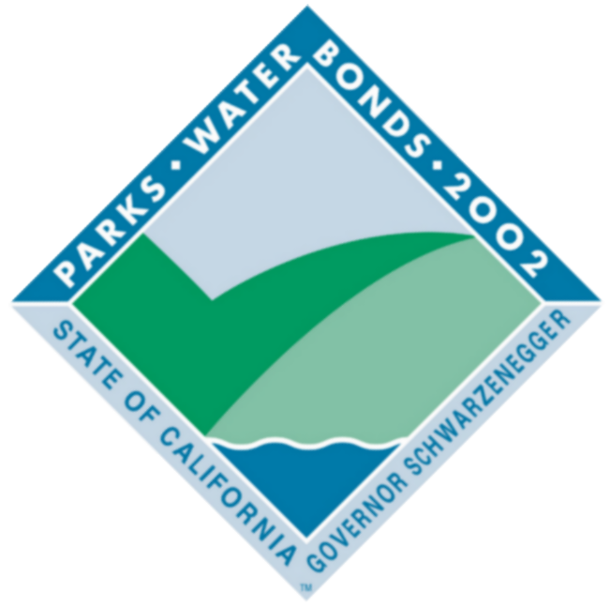
All signs will contain the following minimum language:
The name of the director of the local agency or other governing body may also be added. The sign may also include the names (and/or logos) of other partners, organizations, individuals and elected representatives as deemed appropriate by those involved in the Acquisition.

Logo
All signs must contain a universal logo for the Parks and Water Bond Acts (see above). Your Grants Administrator can provide a copy of the logo via email. A copy will also be posted online at the following address: http://www.resources.ca.gov/bonds_prop50sncgrantsprogram.html. The logo must be mounted in an area to maximize visibility and durability. Each side of the logo must be a minimum of 24”. Exceptions may be approved in cases where these dimensions may not be appropriate.

Sign Construction
All materials used shall be durable and resistant to the elements and graffiti. The California Department of Parks and Recreation and California Department of Transportation standards can be used as a guide for gauge of metal, quality of paints used, mounting specifications, etc.

Sign Duration
Project signs must be in place for a minimum of four (4) years.

Sign Cost
The cost of the sign(s) is an eligible Project cost. More permanent signage is also encouraged (e.g. bronze memorials mounted in stone at trailheads, on structures, etc.).

Appropriateness of Signs
For Projects where the required sign may be out of place or where affected by local sign ordinances, the Grants Administrator in consultation with the Grantee may authorize a sign that is appropriate to the Project in question.

Signs on State Highways
Signs placed within the state highway right-of-way may require a Caltrans encroachment permit. Contact your local Caltrans District Office early in the planning phases for more information.

State Approval
The Grantee shall submit proposed locations, size, number of signs and language for review prior to ordering signs.

APPENDIX L – APPLICATION CHECK LIST

Application Packets should be organized in the following order. Clearly number and label each item and number all pages in sequential order. The appropriate number of copies should be provided. Staple or bind packages with binder clips only. Do not put in folders or notebooks. Note: Incomplete applications will not be evaluated or considered for funding.

Submit 7 copies (one unbound original and six copies) of items 1 - 7:

1. | Completed Application Form - (Appendix E)
2. | Acquisition Overview (one page maximum)
3. | Project Proposal Narrative (eight page maximum)
4. | Long Term Management Proposal
5. | LAND ACQUISITIONS
 | a. Information Form for Land Acquisitions
 | b. Location Map
 | c. Assessor's Parcel Map
 | d. USGS 1:24,000 Scale Quad Map
 | e. Natural Features Map
 | f. Site Drawings or Map
 | g. Legal Description of Property
 | h. Restrictions/Encumbrances
 | i. Photographs
6. | WATER RIGHTS ACQUISITIONS
 | a. Water Rights Application Number
 | b. Recent copy of Water Permit and/or License
 | c. Copies of any Orders to Change, if applicable
d. Recent copy of Report of Permittee or Report of Licensee,
whichever is applicable
e. Documentation of non-appropriative water right ownership
including deeds, title, lease, etc., if applicable
7. | Timeline

Submit 3 copies (one unbound original and two copies) of items 8-18:

8. Signed Authorizing Resolution from Governing Body
9. Purchase Option
10. Evidence of Willing Seller
11. Evidence of Local Support
12. Proof of Compliance with CEQA
13. Operations & Maintenance Agreements
14. Other Sources of Funds
15. Evidence of Eligibility for Nonprofit Applicants
16. Disadvantaged Community
17. Local Water District Applicant Information
18. Sierra Nevada Conservancy Narrative (if applicable)

APPENDIX M – DEFINITIONS

Unless otherwise stated, the terms used in these grant guidelines have the following meanings:

“Acquisition” means obtaining a fee interest or any other interest, including Easements, leases, and development rights in property and/or water rights.

“Applicant” means an eligible organization requesting funding from a Program administered by the State.

“Bond” or “Bond Act” means Proposition 50, the Water Security, Clean Drinking Water, Coastal and Beach Protection Act of 2002.

“Census Designated Place” (CDP) is a census geography used by the U. S. Census Bureau that is a statistical entity, defined for each decennial census according to Census Bureau guidelines, comprising a densely settled concentration of population that is not within an incorporated city, but is locally identified by a name. CDPs are delineated cooperatively by state and local officials and the Census Bureau, following Census Bureau guidelines.

“CEQA” means the California Environmental Quality Act, Public Resources Code Section 21000 et seq.; Title 14, California Code of Regulations, Section 15000 et seq.

“Community” means a population of persons residing in the same locality under the same local governance, such as a city, town, county, or named unincorporated area.

“Conservation Easement” is any limitation in a deed, will or other instrument in the form of an Easement, restriction, covenant or condition which is or has been executed by or on behalf of the owner of the land subject to such Easement and is binding upon the successive owners of such land, and the purpose of which is to retain land predominantly in its natural, scenic, historical, agricultural, forested or open-space condition. (Civil Code Section 815.1)

“Disadvantaged Community” means a Community with an annual median household income that is less than 80 percent of the statewide annual median household income.

“Easement” is an interest in land entitling the holder thereof to a limited use or enjoyment of the land in which the interest exists.

“Fair Market Value” means the value placed upon property as supported by an appraisal that has been reviewed and approved by the California Department of General Services or other designated authority. The State will not participate in an acquisition that is above Fair Market Value, even if non-State funds are used to supplement the difference between the Fair Market Value, as defined, and the price of the property.

“Fund” or “Funds” means Proposition 50, The Water Security, Clean Drinking Water, Coastal and Beach Protection Fund created pursuant to Water Code Section 79510.

“Grant Agreement” means a contractual arrangement between the State and Grantee specifying the payment of Funds by the State for the performance of specific objectives within a specific Project Performance Period by the Grantee.

“Grantee” means an Applicant that has an Agreement for grant funding with the State.

“Grants Administrator” means an employee of the Resources Agency who manages the grants.

“In-Kind” means non-cash donations, from governmental or private sources, and includes volunteers, materials and services.

“Indirect Costs” means expenses of doing business that are of a general nature and are incurred to benefit at least two or more functions within an organization. These costs are not usually identified specifically with a grant, Grant Agreement, Project or activity, but are necessary for the general operation of the organization. Examples of Indirect Costs include salaries and benefits of employees not directly assigned to a Project; functions such as personnel, business services, information technology, janitorial, and salaries of supervisors and managers; and overhead such as rent, utilities, supplies, etc. These costs are also known as “overhead” costs.

“Nonprofit Organization” means any nonprofit corporation formed pursuant to the Nonprofit Public Benefit Corporation Law (Division 2 (commencing with Section 5000) of Title 1 of the Corporations Code) and qualified under Section 501 (c) (3) of the Internal Revenue Code.

“Other Sources of Funds” means cash or In-Kind contributions that are required or used to complete the Acquisition beyond the grant Funds provided by this program

“Project” means the Acquisition to be accomplished with grant Funds.

“Project Performance Period” refers to the beginning and ending dates of the Grant Agreement. Eligible costs incurred during this period may be funded from the grant.

“Project Scope” means the description or activity of work to be accomplished by the Project.

“Proposition 50” - See “Bond”

“Region” – See geographic area covered by the program described on page 2, and map of area in Appendix B.

“State” means the Secretary for Resources or his/her representative.

"Stewardship Plan" means a plan to provide ongoing implementation and management associated with the Acquisition of a Conservation Easement.

“Working Landscape(s)” is a place where agriculture and other natural resource based economic endeavors are conducted with the objective of maintaining the viability and integrity of its commercial and environmental values. On a working landscape, both private production, as well as public regulatory decisions account for the sustainability of families, businesses and communities, while protecting and enhancing the landscape’s ecological health.

