APPENDIX l – SIGN GUIDELINES

Types of Signs
1. Construction - A sign acknowledging the funding source is required during construction.
2. Post Completion – A funding acknowledgment sign must be installed before the final project inspection and remain in place for at least four (4) years from date of project completion. The size of the sign is not prescribed; however, the funding source logo must comply with minimum size requirements and all required language must be included.
If appropriate, the same sign can be used during construction and completion.

Sign Language
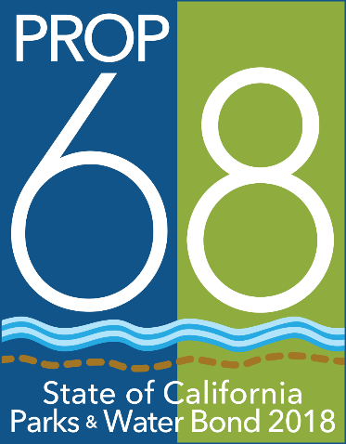
Project Title/Description
Another project funded
through the California
Natural Resources
Agency for
multibenefit green
infrastructure projects
GAVIN NEWSOM,
GOVERNOR
Wade Crowfoot, Secretary
for Natural Resources
All signs must contain the language shown to the right. The name of the director of the local agency or other governing body may be added, as well as the names (and/or logos) of other partners, organizations, individuals and elected representatives.

Logo
All signs must display the Parks and Water Bond Act logo. The logo is available at http://resources.ca.gov/grants/logo-art/. The logo must be mounted in an area maximizing visibility and durability. The logo must measure a minimum of 24” tall. When appropriate, exceptions may be approved at the State’s discretion.

Sign Construction
All materials used shall be durable and resistant to the elements and graffiti. The California Department of Parks and Recreation and California Department of Transportation standards may be used as a guide for gauge of metal, quality of paints used, mounting specifications, etc.

Sign Cost
The cost of the sign(s) is an eligible project cost. Permanent signage is encouraged.

Appropriateness of Signs
For projects where the required sign may be out of place or affected by local sign ordinances, the grants administrator may authorize a sign that is more appropriate to the project.

Signs on State Highways
Signs placed within the state highway right-of-way may require a Caltrans encroachment permit. Contact the local Caltrans District Office early in the planning phases for more information. For District Office locations, see http://www.dot.ca.gov/contactus.html.

State Approval
Grantee shall submit the proposed number, location(s), size, and language of signs for review prior to ordering signs. Final funds for projects will not be reimbursed until signage has been approved and installed.

